Analysis Stage:

Introduction:
The idea for my game is a 2d platformer, where the title is currently BOSH – for now. The user will play a character who attempts to climb a skyscraper while fighting off enemies. During the climb, they will have to make it through difficult levels while using items that are given to them throughout the game. When it is opened, it will have a start menu that allows the user to start or replay any level they have completed. It will also have an in-game menu that allows you to change settings or leave the game. The game will be controlled by a keyboard. But, as many people have different preferences for what keys they like to press, a feature I would like to add is the ability to rebind the controls to what they would like.
As I enjoy similar games to this idea, like Celeste and Hollow Knight, I want to create another one for myself and others to enjoy, the mechanics of both games are fun and interesting, which is something I would like for mine. The original plan is to give the user items that help them to move across levels and avoid enemies like in both Hollow Knight and Celeste. They also have a good storyline, which isn’t as important to my game, but is certainly I feature I would like to include.
For the project to be a success, I will need to get feedback from people which will help me to analyse the features that will make the game enjoyable. I will give questionnaires and surveys to my stakeholders throughout the project to first; find what characteristics they think is important for a game like this. After that, I will get them to test the program and give them another survey based on their previous answers in order to improve the game, the reason for this is that it aids me in knowing what features to prioritise and focus on to improve the game. I’m using this method instead of just using my ideas as it provides another perspective on the development of the game, allowing me to do things that I otherwise wouldn’t have done, improving the final product.

Research:
Existing solutions:
There are many 2d platformers with similar mechanics to my game, I have researched a few examples which I think are similar to my idea.
Program 1: Celeste
Sources: 1. Celeste | Interface In Game | Video game UI 2. Celeste - Chapter 1 - Strawberries 3. Screenshot from the game 4. Stuck on opening screen 5. Stuck on title screen
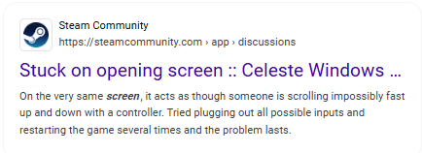
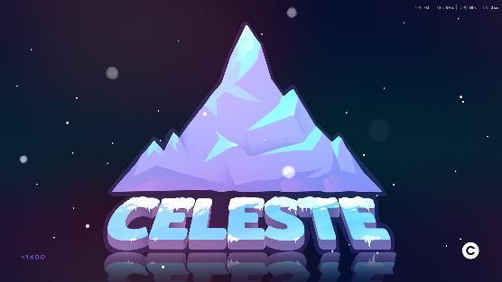
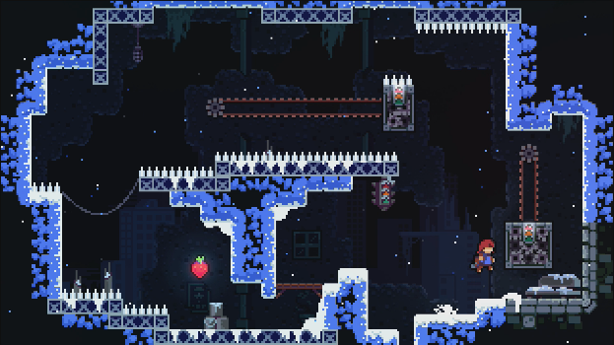
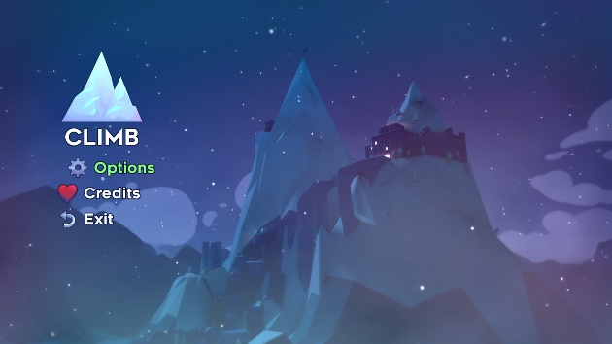

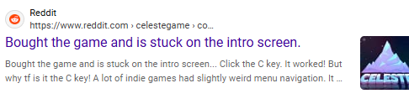

This game starts off a simple menu with a few different options including climb, options and exit, obviously displaying to the user what they can select and do in the game. The menu is set in front of a backdrop of a mountain, which is the main part of the game – where you climb it – again displaying what the game is about.
Despite the menu being simple and understandable, before that, there is a start screen where you have to press ‘C’ to begin, this confuses many people as they think that it’s a copyright symbol, and there are many examples of people being stuck at the very start of the game on places like steam community and reddit, indicating how this is a puzzling way to begin.
After you have started playing, each screen is small, but the platforming is difficult. Even though that may sound annoying or enraging, it doesn’t take long to complete in a successful attempt, so you can retry the level very quickly and get back to the point you were before in a small amount of time.

Things I would like to incorporate into my project | Things I wouldn’t like to use in my project
A large quality of life feature that is overlooked a lot of the time is called ‘Coyote Time’ where the character can still jump for a fraction of a second after leaving a platform, this makes it much easier to time jumps and makes the experience more enjoyable. So, this is something I would like to add into my game. | The controls are very simple – just a dash and a grab added onto the usual movement controls, even though these can be used for complex mechanics. I would like my game to have a specific powerup for each level, which I think would add more variety to the game.
I would like to use the 2d, pixel art style that Celeste uses, I think that in many parts of the game it can look very good, which will appeal to the user and improve the overall experience. I would use this as its easier to create than other art styles due to its simplicity. This also | The game starts off as 3d and then moves into 2d, while this is interesting, I would like my whole game to be 2d as to not confuse the user at first as the switch may be disorienting and give them a false idea of what the program is like.
Small screen size, this allows the user to see the entire level and lets them think about what they should do at the start to try and complete it. This also means that each screen is short and doesn’t take long to complete, which is something I would like to adapt into my project. | Celeste also incorporates screen shake into the levels, I am not fond of this as it can be distracting and makes it harder to see the level, even if it as used to enhance gameplay and make it more immersive.
The menu is clear about every button’s purpose and what will happen if you press them. This is a helpful to include into my project to easily display to the user what’s happening. The game also allows for opening the menu in-game, letting them change settings like key binds and music volume, which is something I would also like to take into my game. | As previously mentioned, the very start requires you to press ‘C’ to begin the game, this confuses many people as they either don’t see it or think it’s a copyright symbol. I would like to make the start button something more intuitive to press, like the spacebar or enter button.
The game allows for the changing of key binds if the user doesn’t like the original ones, this is massively helpful for the user experience and improves the quality of the game. | The game uses ‘X’ and ‘C’ as the starting controls along with ‘ASD’ I think that those buttons are hard to press and can result in stretching/twisting your fingers in weird ways to press them. This can hurt or tire out your hand. I would have the buttons be used in a more ergonomic way that allows the user to more easily press them.

Program 2: Hollow Knight
Sources: 1. HK start menu 2. HK gameplay 3. HK Charms 4. HK Map
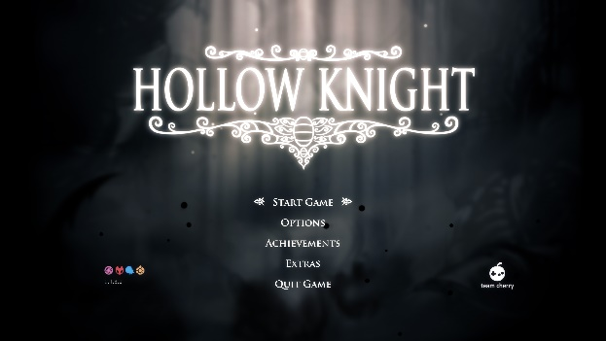
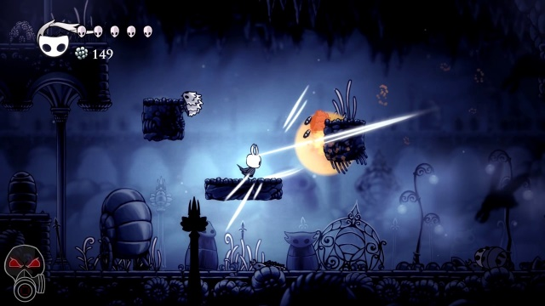

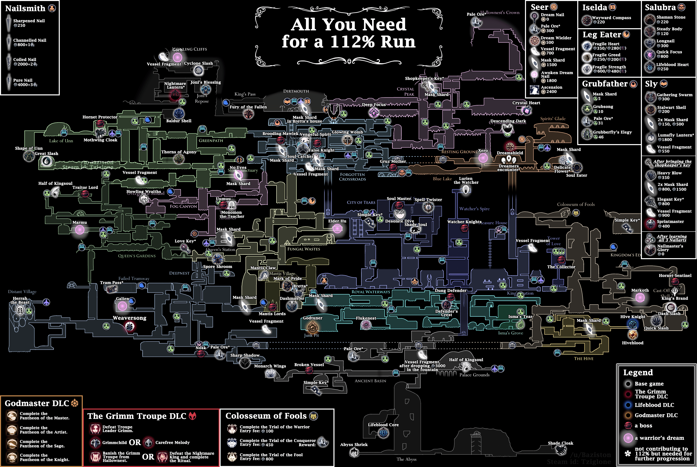
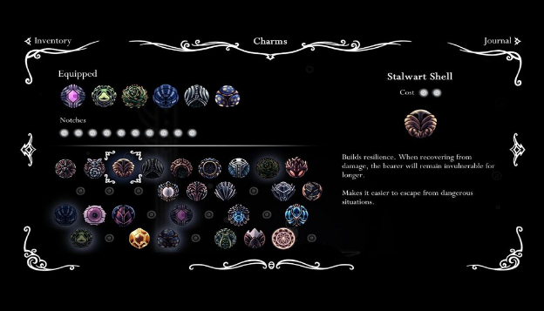
Similar to celeste, the game begins with a simple start menu that clearly displays all the options available to the player, including start, options and exit. The menu has a theme like the game, instantly highlighting the style of the program to the user.
The player character travels around a map where it fights off enemies using its abilities like dodging and certain different attacks, some of these attacks can also be used for platforming, like bouncing off of spikes or enemies.
During the game, you can unlock ‘charms’ which give certain abilities like extra lives or effects that help you in battle – like regeneration or extra lives – or in platforming – like an extra jump or dash. These abilities cost energy and they allow you improve in the game, getting to places you otherwise wouldn’t be able to.
Things I would like to incorporate into my project | Things I wouldn’t like to use in my project
As the menu screen is simple to understand and easy to navigate, this provides a good user experience and is something I would like to include in my game. | The whole world is a large map which many different places on it that you can gradually unlock, this can be very overwhelming to the user at first as they don’t know what anything is or where to go, which can also be frustrating. I would prefer my game to have a linear route which you take rather than spending a lot of time not knowing where to go.
There are many different mechanics that the player can utilise to their advantage, that allow them to jump higher or dash in the air. As this is something that would be important for my game to allow me to add complexity while keeping the fun platforming, I would like to add this to my project. | As there are so many different charms at first, similar to the map, this can be too complicated or confusing for the user, so I would only have a few that impact gameplay as to not be too complex at first.
During the game, there are many enemies which you can fight for small rewards, providing the user with experience or money, I would like to incorporate the potential to fight enemies to make each level more difficult and complex – rather than just jumping around. | The game has certain places where you can save your game, meaning that if you die and haven’t saved in a while, you are forced to restart from a long time ago and lose a lot of progress, I don’t like this and would like the game to save often or whenever the player exits. This would improve the experience for the player, as losing progress can be very frustrating and annoying.
The game has many ‘boss battles’ that take place where the player character has to fight a much stronger enemy than usual, which has its own special ways of attacking that the user has to learn how to avoid. As this may be difficult to add, I would like to adapt it into the end of each level, but only if everything else is to a good standard.

Program 3: Ori and the Blind Forest/ Will of the Wisps
Sources: 1. OatBF menu theme 2. Ori screenshots 3. Ori Map4. Ori Skill Tree
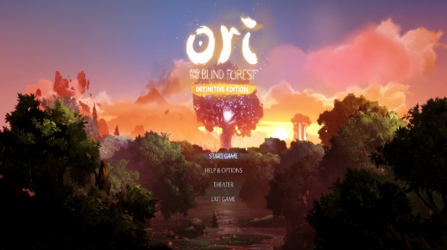
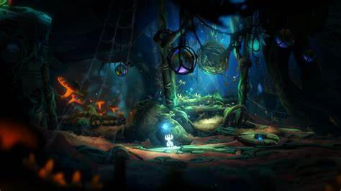

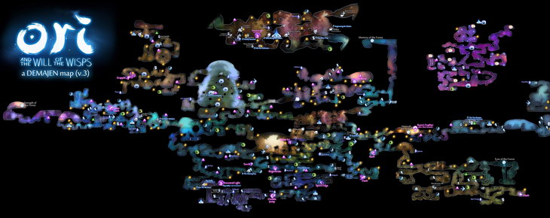
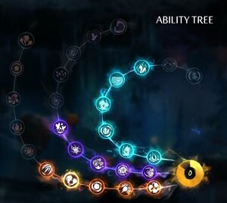
Like Hollow Knight and Celeste, the game starts off with an easy to understand and navigate menu places in front of a beautiful backdrop of where the game will take place, displaying to the user the theme of the program and the centre point of the game – the large tree.
During the game, each level has a massive amount of detail, with foreground elements and a busy background behind the player, fully immersing the character in the forest that they are in.
A large part of the core gameplay is the presence of an ‘ability tree’ which, similar to Hollow Knight, can be unlocked by the player, giving them certain abilities like different attacks or more ways to move.
Things I would like to incorporate into my project | Things I wouldn’t like to use in my project
Like Celeste and Hollow Knight, the menu screen is simple to understand and easy to navigate, this is something I would like to include in my game. | The game is more centred around travelling and fighting enemies, plus the story element, while I would prefer my game to be more platforming focused.
The game adds more mechanics as you progress, like Hollow Knight and also Celeste to an extent, allowing you to get to places you otherwise couldn’t, continuing the story. I would like to incorporate this into my game, adding more ways to move after each level. And potentially allowing the user to retry the level with the new mechanics to unlock things they previously couldn’t. | The ability tree may add too many different things which could be confusing to the user at first, I would not want to include this as I would like the start to be as simple as possible to allow for a wide range of people to enjoy the game.
Large amount of detail - each screen of the game looks good and has a massive amount of detail put into each setting; I would like this to be a part of my game when I create it. | The large map may also be confusing for new players, similar to Hollow Knight, so this is not something I would like as an addition to my game.
 | Parallel to Hollow Knight, Ori also has certain spots where you can save your game, again

Stakeholders:
My program will be aimed at boys aged from 15-18 who like to play videogames, as I, and many other people my age, that I know, like to play these types of games, so my game would appeal to them. Due to each screen being challenging to complete, it isn’t aimed at younger children as they may not like it as much as ones in their late teens. My program also isn’t targeted towards older people, the reason for this is they may not enjoy games as much as the target audience.
I hope to include my stakeholders in the design and development process, by regularly checking in with them, for example - every week, to see if my program fits their requirements and does what they expected of it. This can be to check if it’s on track to meet the user requirements and fix it if it isn’t meeting them.

User Requirements:
My user requirements:
The necessary features of this game:
- A simple start menu where the user can choose to begin or exit the game.
- Basic movement controls that allow the user to move back and forth and jump/double jump, these will be controlled by the arrow/ASD keys and the spacebar.
- Allowing the user to open a menu in the middle of the game, letting them use settings – like changing the volume/key binds - or exit the game. This means that they don’t have to restart the game to change any settings and can just do it quickly and easily from inside the program.
- Spawning at the start of each screen when the character dies and not taking long to respawn – 1 second at most – to allow the player to quickly retry the level without wasting any time.
Features I would like to add:
- A level select screen where the user can choose what level they want to play after it has been unlocked.
- Enemies that the player can interact with, e.g. fighting. If the character is touched/shot by the enemy, they will be reset to the beginning of the screen, providing an extra challenge and complexity over just jumping around.
- Extra movement and powerups unlocked after each level which give the player many more ways to move, e.g. propelled by an explosion/rope swinging, leading to a more fun and interesting experience, where the user has to chain together different abilities to complete each level.
I would add If I had time at the end:
- Similar to Celeste’s ‘golden strawberries’ feature which resets the player to the beginning of the level when they die, providing an extra hard challenge for the player. I would like to add a setting (called ‘hard mode’ for example) that, once all the levels have been completed allows the user to replay the level, but instead of replaying the screen when they die, makes them replay the entire level.
- A multiplayer game mode where you can fight against your friends trying to knock them off using powerups given to you – like in super smash bros or similar games.
- The player being able to earn coins, letting them buy cosmetic items in a shop, like hats or clothes.

User requirements Table:
Green – Essential Yellow – Desirable Red - Optional
Feature | Sub-Feature | Explanation | Justification | Importance
Start menu/ in-game menu | Start button | A button that will take the user to whatever level they were on when they last played, or if they haven’t, it will take them to the first level. | All of the games that I analysed had a clear start button that began the game when clicked. This allows the user to begin the level when they would like instead of instantly being thrown into the action as to not let them miss anything important that happens at the start.
 | Settings button | A button that can be pressed taking the user to the game settings, this lets them change things like key binds and game/music volume. | All of the games I analysed also included this feature at the beginning. It’s helpful as it allows the user to change the volume in-game if it’s too loud/quiet instead of changing the system/headphone sound, potentially messing other things up on the computer making them too loud or quiet.
 | Settings Menu | A working settings menu, that allows the user to change the volume, and the controls to what they prefer. | If the game is too loud/quiet for the user, the ability to change this would be incredibly helpful for the user’s overall satisfaction of the game. This is similar with allowing them to change the controls to fit how they would like to play.
 | Title screen | Opening screen of the program displaying the name of the game and buttons available to press. | Like the previous sub-features, all three of the programs I researched had this feature. Where the name of the game is clearly visible, indicating to the user what game they are playing.
 | In – game menu | A menu that can be opened using a button that lets to change settings/exit to menu while in game. | If the user’s game sound is too loud or if their key binds are not correct, they will not be able to change them without closing and reopening the game, similar to the justification for the settings button. This can be fixed by having an in-game menu that will fix their problem.
Gameplay | Simple movement mechanics | The ability to move the player around and have them jump/duck plus another extra way of moving to add to the gameplay e.g. a double jump. | For the user to move the character around the level they need to be controlled by the player and given the capability of movement to allow the game to be played.
 | Fun and more complex movement | Extra abilities that are given to the player to allow them to dash or jump higher or propel themselves off in a certain direction that adds more complexity and fun to the simple movement. | If the simple movement mechanics are the only way to move, this could make the whole experience more boring and less fun, providing fewer ways to complete a level. Whereas, if there were more ways to progress with more mechanics, this opens the game up for added creativity and increased ways that people can think of in order to complete a level. | Very desirable
 | Sound effects | Noises that play when an event happens in-game, like a jump or the player dying, these can be created manually or by using royalty free ones online. | This will add to the overall quality of the game, improving the user experience. Although it may be hard to find/create sounds that fit the theme of the game, they will massively improve the game by adding atmosphere and enhancing the immersion for the player.
 | Enemies | Opponents that try to stop you from completing the level that you must either avoid or fight to survive, they would have ways of attacking like swords up close and lasers from afar that you must avoid. | A simple game that just requires jumping around to complete levels would be too simple in my opinion and wouldn’t be as fun to play, simple enemies – not rage inducing as I would like my program to be enjoyable – would add an extra layer of intricacy, hopefully improving the quality of the game as there’s a wider variety of levels.
 | Boss Battles | A boss at the end of each level that the player must fight in order to complete it. They are harder than usual enemies and should have more weapons and health than the average opponent. | Again, this would add more variety to each of the levels and complexity to each stage, finishing would feel like more of an accomplishment, providing the player with more enjoyment after completion than without the difficult fight.
 | Fast respawning | Respawning quickly at the start of each screen when the player dies to allow them to quickly retry the level. | Even though the platforming may be difficult, there are many frequent checkpoints that the player gets reset to when they die that are close to wherever it was, this allows them to retry the screen quickly and make the game enjoyable as it isn’t spent doing jumps that you have beaten before.
Extra Features | Cosmetic Store | A shop where you can buy cosmetic items for your character, these can be different types of hats or clothes that can be bought using in-game currency. | People may not like the original design of the character or just may want to stand out from others; they can use the cosmetic shop to customise their character if they would like. | Difficult to add
 | Multiplayer battles | A game mode where you can fight against your friends using powerups given to you during the fight. Or play through the levels with them in a co-op game mode. | As the original game would be single player, this leaves it less accessible for people to play compared to a multiplayer game. For example, if you were with your friends and wanted to play a game with them, this program wouldn’t be an option at first. But it would be open to a wider range of people if multiplayer was a feature of the game. | Very difficult to add
 | Hard mode | Where the player starts from the beginning of the level when they die compared to just the start of the screen they were on, adding an extra challenge to the game. | This would be a much harder challenge compared to the normal game that not everyone can complete. This will provide players that have beaten the game with an even more difficult task. As its much harder it may not be as enjoyable as the main game, so its optional/only playable after the game has been completed. | Not a necessary feature

Limitations:
I have labelled some of my features as optional, which means that its something that I or my stakeholders would like to be present in the game, but they would be too difficult/ time consuming to add, or something I would integrate at the very end, because of this, I have decided their importance is red and given a reason as to why I think that is.
Cosmetic store:
The results of the survey show that this would be a part of the game that many people will use as 16/18 voted yes and 1/18 voted no. Because of this, it’s a feature I would like to add to my program, but due to the amount of added time that coding and asset creation will take, it’s only something that I will add at the very end, if my game is up to a good standard of gameplay and there’s enough levels (3-4).
Multiplayer Battles:
Again, the survey results indicate that this would be a very welcome feature as many people enjoy playing games with their friends. But, due to the massive difficulty of making multiplayer just work, with the added trouble of making it work well, this is definitely something I will not be doing unless I have a lot of time to spare.
Hard Mode:
This is a feature of other games that I enjoy and find interesting, even if it can be annoying and incredibly hard at times. Therefore, this is a feature that I would like to integrate into my game. As this is certainly not a feature that’s necessary or improves the game by a large margin, it is not one that I would prioritize over the other more important ones like interesting and fun platforming/mechanics.

Stakeholder Survey:
To find out what features of my program that would be most liked by my stakeholders, I gave a few of my friends who liked videogames (aged 16-17) a short survey asking questions that would influence the choices I make when programming. These questions are as follows:
- Do you like to play video games?
This is to indicate the amount of people taking the survey who have an idea about what makes a game fun to them and how useful their input will be on the survey.
- What are your favourite games to play?
This is to find out what games are popular, and which ones have been played the most, this shows what game aspects the stakeholders have experience with and are more qualified to comment on.
- Please rank these based on how important they are in a 2d platformer
This is to find out what games are popular, and which ones have been played before, allowing the stakeholder to use their experience in previous games to influence what I include in mine, and what I should prioritise to provide the best user experience possible.
- On top of WASD/arrow keys, what other keywords would you use for other movement buttons?
The point of this simple question was to find the most popular key binds that people use while playing games, so that the default ones for my game would appeal to the widest range of people, allowing them to start immediately rather than wasting time trying to figure out the best keys for them.
- What is more important – mechanic variety/level variety
This is another simple question that is purely just to figure out which of mechanic or level variety that people prefer more, letting me know what i should prioritise in my game.
- Would you use a cosmetic store?
Again, this a simple question to find out whether this would be a welcome addition to the game or not.
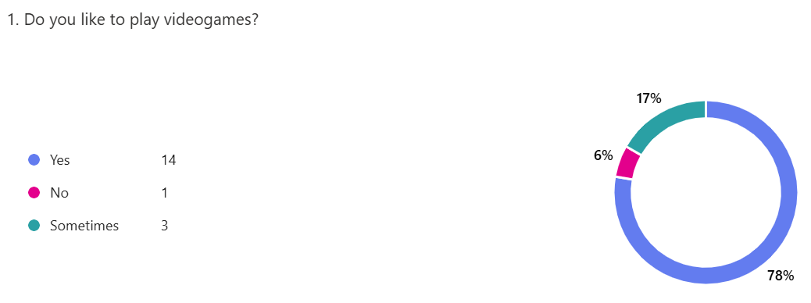
As most of the answers are yes, this shows that the question is doing its purpose by showing that the stakeholders have some sense of knowledge on games and therefore are helpful in providing information for the survey.
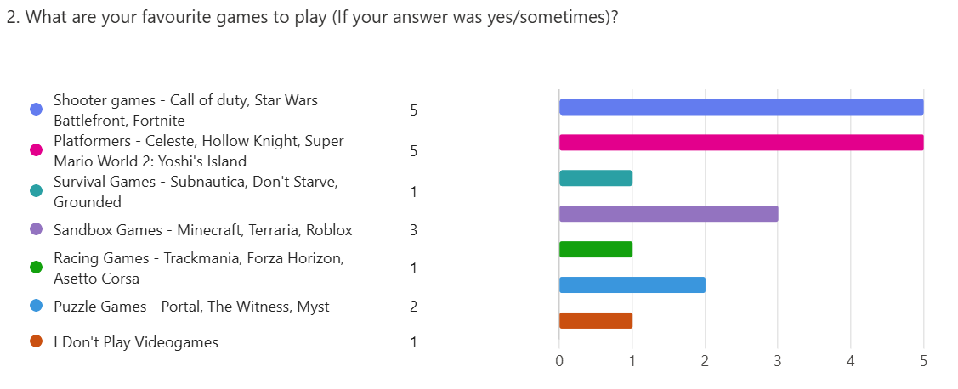
These answers indicate the amount of people that have played each genre of game, highlighting which ones they know the most.
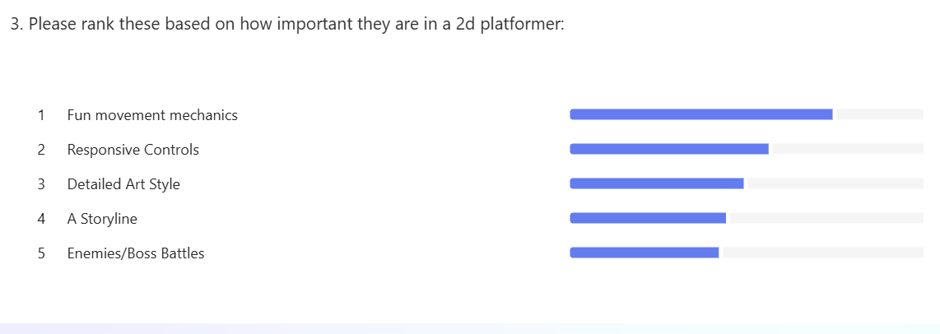
The responses to this question show to me that the and how I should prioritize them based on which ones are decided to be most important.
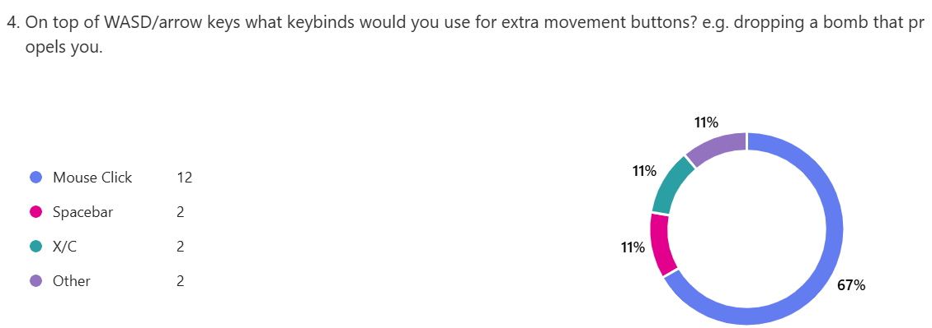
The answers to this question indicates what the most popular controls are and which ones I should default to each action in game. As the mouse click is by far the option with the most votes.
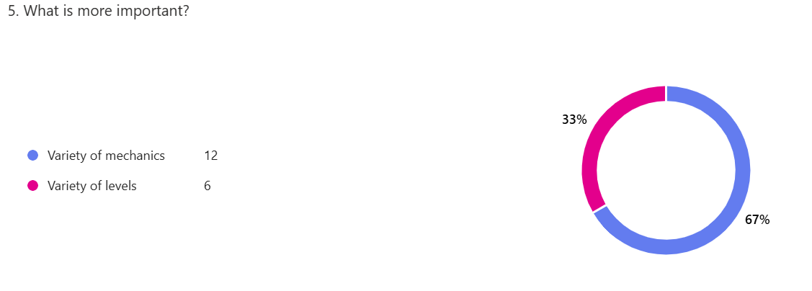

Again, this question indicates which features I should prioritize through which option the stakeholders believe is more important. As the variety of mechanics has the most votes, more time will be spent on developing that area of the program.

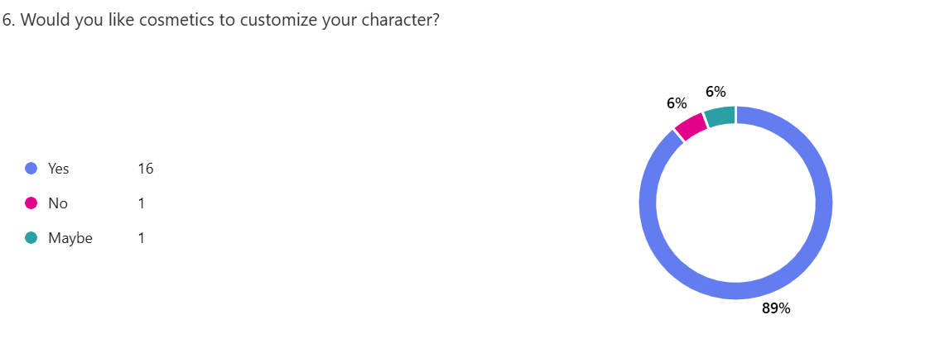

The answers to this question fully indicate that the stakeholders would like the option of character customization. Thus, this is something I should add if I have time, due to this being a low priority feature.

Hardware and Software Requirements:
To design this game, I will be using unity and will be coding in C#, the operating system I will use is Windows.
Hardware:
- As I will be making the game in unity, the hardware should just be able to run the program, because it’s a 2d game the requirements shouldn’t be very high as not much processing power is needed to render it.
- A keyboard and mouse should be used to provide inputs for the game as this is standard for programs similar to this.
- As it should have sound effects, speakers/headphones should also be used.
Software:
- The game will be made in unity, so the only Software Requirements would be an operating system that can run it.
- Need to download the game to play it.

Features that Make this Problem Solvable by Computational Methods:
The program will use unity to create the movement of the player, requiring a large number of calculations to simulate the player in motion, especially if it is moving quickly or at an angle. A computer is able to perform these calculations very quickly, allowing the game to run smoothly, improving the user experience.
Aspects of the game will have tasks that run concurrently, like the playing of sound effects and movement of the player and enemies at the same time. On top of this, there will be collision and player detection to check if the player dies – to be able to reset them to the beginning - or is near an enemy – to allow the enemy to target the player character. Both these tasks will be constantly running to always be checking for the player.

This problem is amenable by computational methods for the following reasons:
Decomposition - The main aspects of my game can be broken down into multiple separate problems
- The player movement
- Enemies and attacking the player, including the boss battles
- Level creation
Each of these problems would be difficult to complete, but accomplishing all of them to a high standard would put my game in a good position to be finished.
Abstraction - Many smaller problems within the program would be abstracted, making them far more solvable.
This means, when I am making something like the movement, I will ignore other factors that make it more complicated and focus on them later, e.g. more ways to move, as those aren’t as necessary. Another example of this would be just focusing on the gameplay aspect of each problem, rather than how it looks, and centre the attention onto that once I am happy with how it is to play.

2d Platformer Design:
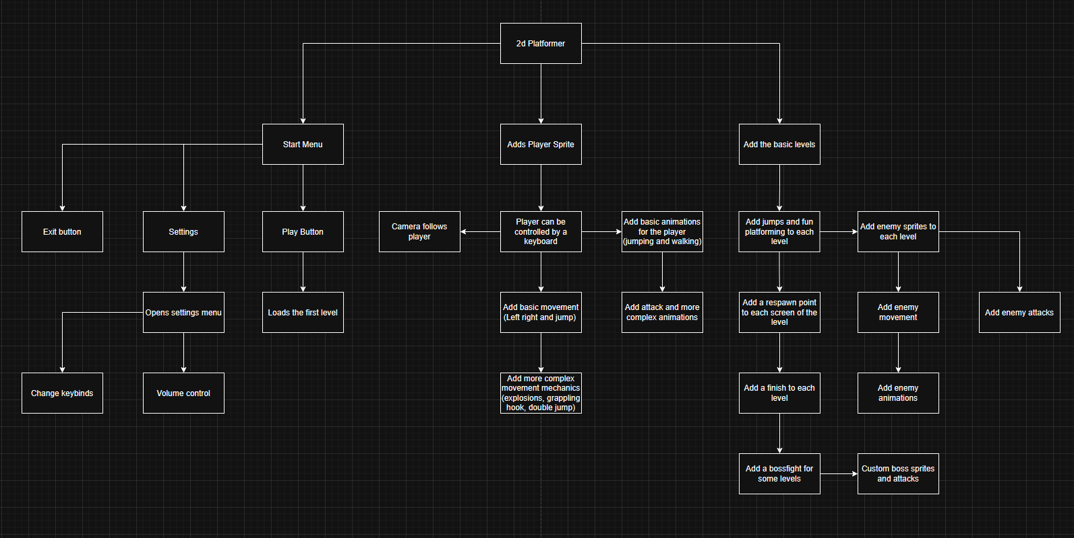
Structure Diagram:

This structure diagram is split into 3 parts; these show the overarching components that I want to add to my game. The first part is the start menu, I chose this as it’s a fundamental part to the beginning of a game, as it allows the player to change options like volume and controls before the game has started.

TO DO:
ADD IMAGE + EXPLANATION OF STRUCTURE DIAGRAM FOR EACH STAGE OF DEVELOPMENT
TAKE VIDEOS OF PROOF OF MY COMPLETED STAGES - FIX THE STAGE 2 VIDEO
END TESTING – AFTER FINISHING DEVELOPMENT, ADD PAGE NUMBERS FOR EACH REFERENCE
FINISH STAGE 6 PLAN

Stages of Development Plan:

Stage 1:
Before I go in depth for any feature of the project, like mechanics, level design and user interface, I should make a simple version of the game. This will include simple movement and a few jumps to test that the base code works properly.
The 1st version will have the following features:
The ability to move left, right and jump, make sure that the movement is enjoyable and responsive from the start. It will also feature the camera following the player, so they can see it at all times.
Add some objects to the scene to see how they interact as they should. For instance, being able to stand on top/ not walk through.
Add a respawn platform for the player to go to when they die/fall off the map. Plus, a way to teleport the player between levels, as respawning and moving between the levels will both require moving the player, I can reuse the same code for both purposes.

Test No. | Description | Type of test | Test data | Expected  Result | Actual  Result
1 | Can the  player move? |  | Input  movement button | Player moves
2 | Does the camera follow the  player? |  | Input movement button | Camera moves with the player

3 | Can the player interact with  objects? |  | Place player on top of a platform | Player stands on top
4 | Does the player respawn? |  | Move the player off the map | Player is  placed back on its  respawn  point
5 | Can the player jump? |  | Input the jump button | Player jumps
6 | Can the player be teleported to the next level |  | Execute teleport function | Player’s position changes to next level
Video: Stage 1

Stage 2:
To make the game more complete, I will add more features to the game, this includes a working UI that includes things such as settings, a start menu and a pause menu during the game. I have chosen these as they are core components of a UI in most
The 2nd stage will have the following features:
A menu that appears when the game starts, which lets you play the game or enter settings/ the character creator, the menu will be easy and intuitive to navigate, having labelled buttons like ‘Settings’ and ‘Play’ that aid in telling the user what to do. This helps provide an easy-to-use experience that
A pause menu that will let you return to the menu during the game, the game will also freeze when the pause menu appears. The pause menu will contain a button to resume the game, a button for settings and one to return to the main menu.

Test No. | Description | Type of test | Test data | Expected  Result | Actual Result
1 | Does the game start? |  | Press the start button | Scene, and sprites  appear
2 | Does a  pause menu appear? |  | Press the pause  button | Pause menu appears
3 | Game stops when paused |  | Press the pause button | Game objects stop moving
4 | Can you navigate the start menu? |  | Click each button in the UI | Pages switch when the buttons are pressed
5 | Can the start menu be used to change the controls and volume? |  | Click the respective buttons | The user is able to change that setting.
Video: Stage 2

Stage 3:
To further improve the quality of the movement mechanics, I will add more complex actions that the player can execute. These will include:
A double jump that allows the player to jump again while already in the air, potentially playing an animation, letting the player jump further.
A rope/grappling hook that can be shot to attach to the ceiling, to let the player swing across a gap that would otherwise be too large to travel across
A bomb that can be dropped to propel the player quickly in a certain direction.

1 | Can the player double  jump? |  | Press space twice | Player can jump
2 | Can the rope attach to the  Ceiling? |  | Touch the two objects | Rope  attaches to the object
3 | Can the player fire the rope? |  | Press the action button for the rope | Rope moves until it reaches an object
4 | Can the player swing on the rope |  | Move around when rope attached to the ceiling | Rope attaches to the player, allowing them to swing
5 | Can the player throw a bomb |  | Execute function to throw. | Bomb object is created
6 | Does the bomb propel the player? |  | Press the action button for the bomb | Moves the player away from the bomb

Video: Stage 3

Stage 4:

After adding more complex mechanics to the game, I would like to start making it more playable and fun. This means adding things like enemies and fighting, plus changing features to be higher quality, this includes changes such as bug fixes and quality of life changes like the player’s interactions with objects and other characters.
The 4th stage will have the following features:

Enemies that can move towards or fire objects at the player. The player should also be able to take damage from these attacks or by touching an enemy. But, they can fight back using the tools they have been given (bomb/grappling hook) to damage the enemies.

Test No. | Description | Type of test | Test data | Expected  Result | Actual  Result
1 | Do the enemies try to attack the player? |  | Move player towards enemy. | Enemies aggress towards the player, once they get close enough
2 | When hit by an attack, does the player take damage/get reset? |  | Player touches component that damages them | Teleported to the beginning of the screen
3 | Do the enemies take damage from the player’s attacks? |  | Enemy touches player attack. | Enemy takes damage/ disappears.
4 | Is the player able to attack? |  | Press attack key | Player attacks
Video: Stage 4

Stage 5:

Once the base mechanics of the game are functional, I will add levels inside the game for the user to play. These will be simple platforming at the start, that make use of the tools the player has been given after the end of each level. The first level will have X The second level will have X …

Test No. | Description | Type of test | Test data | Expected  Result | Actual  Result
1 | Is the player able to complete each level? |  | Player attempts to complete level | It is possible to reach the end of the level
2 | Does the player receive a new tool at the end of a level? |  | Execute function to give the player a new tool | Player receives it in the tool slot.
3 | Does an image appear to display the unlocked tool to the player. |  | Execute function to give the player a new tool | Image appears, showing the new tool.

Stage 6:
I will continue with the 6th stage when most other parts of the game have been completed, the reason for this is that animations take a long time to complete, so they are a low priority part of the project, as other stages, like movement and level design.

The 6th stage will have the following features:
Animations play for players and enemy movement and attacking, this will add more depth to the game as the gameplay as a whole will seem more complete and alive. On top of this, the UI will have simple animations while navigating, this makes the GUI seem more interactive, making it enjoyable to use.
1 | Does an animation play when the enemies move? |  | Move the enemy | Movement animation plays
2 | Does an animation play while the enemy is attacking? |  | Execute enemy attack function | Attack animation plays
3 | Does an animation play when the player moves? |  | Press the player movement key | Player animation plays
4 | Does an animation play when the player attacks? |  | Press the player attack key | Attack animation plays
5 | Do simple animations play when clicking buttons in the UI |  | Hover mouse over button | Subtle colour change to show selected button
5 | Do simple transition animations play when navigating the UI |  | Click button to change between screens | Transition animation plays to make
6 | Does the Controls menu work |  | Press buttons to change key binds. | Menu appears to change key
7 | Do sounds play when certain actions happen like a player death/  explosion |  | Execute function that causes the sound. | Noise plays.
8 | Does an animation play when the player dies? |  | Respawn the player | Transition animation plays so respawn is seamless.
Video: Stage 6

GUI Design:
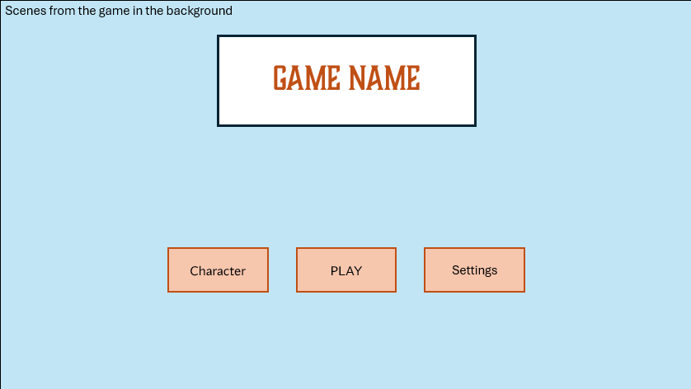
The game will open to this page which contains the title of the game, and multiple buttons below. I have done it in this way as it makes the name more prominent, letting the player know what game it is instantly, as opposed to something else being more noticeable, making the game name less obvious. The buttons are just below the title, in an easy-to-read font that stands out compared to the orange background. I have decided to use the colour orange as it stands out against the blue background, which is blue as it will contain backgrounds from the game, which is mainly set outside, with a blue sky.

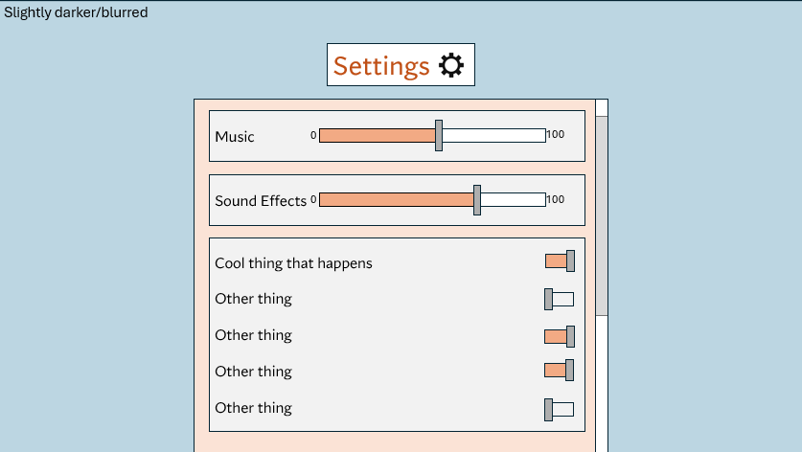
Back arrow indicates that it will bring the user back to the main menu. This is used instead of ‘back’ as it became too cluttered with words and I preferred it to be more simple
The settings background is slightly darker compared to the main menu, the background will also become blurred; I think this helps to indicate that it is a sub-page and take the attention away from the background and focus on the main point of the page
Each button takes the user to its respective page
Background contains scenes from the game, so the placeholder colour is blue, as it is abundant due to the game being outside

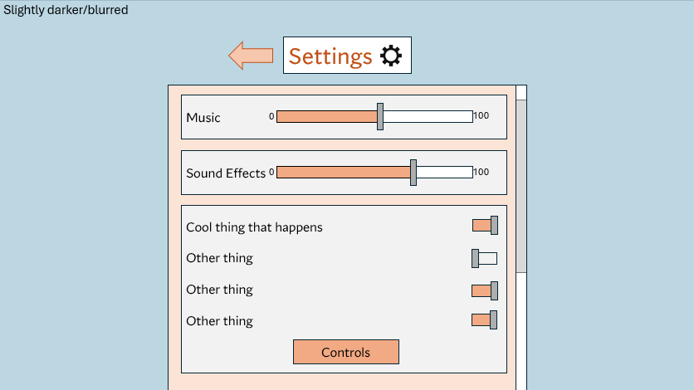
When the settings button of the previous layout is pressed, this page will appear. There is a title at the top of the page telling the user it is the settings, plus an icon, just in case the user isn’t able to read English. This tells them they are in the settings. Below the title, there are different sliders and buttons you can press. For the sliders, there are contrasting colours: orange and white, which is a good visual representation to show how far along it is. Similarly, the buttons have that feature, where it is obvious if they are on or not. These are helpful as they make navigating settings as easy as possible.

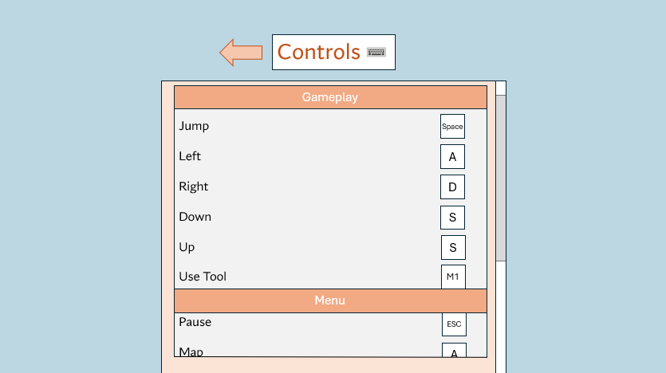
After the Controls button has been pressed, this page appears, it shows the user what each key does in game, this is helpful in case they do not know. The background is a different colour to the key binds’ background, this makes them stand out more and easier to see. I have also used a keyboard icon next to the title to help indicate the usage of the page, like the settings icon. The user can also change the keys by clicking on them. There is also a heading that groups the controls into categories, this makes a certain one easier to find as they are grouped together, as opposed to all in a list, which is harder to sort through.

Clicking this will allow the user to change the key the action is bound to
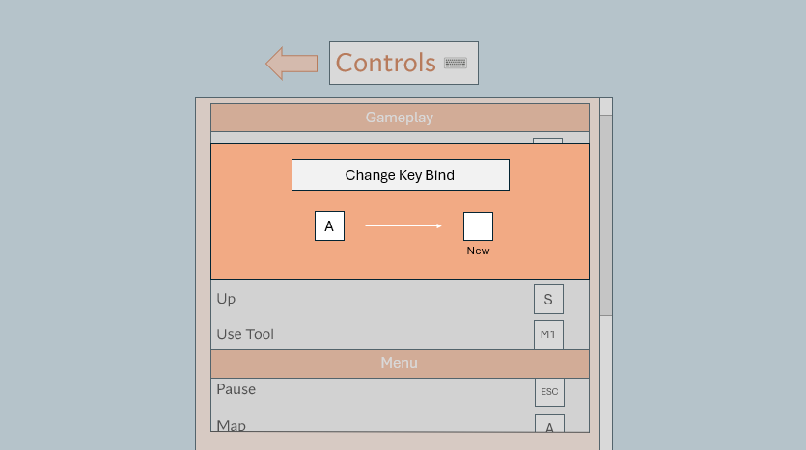
The background is again darker, to indicate what page the game is focused on.
When the user tries to change their key binds, this window will appear, where they can press any button to change the key. The background becomes darker as it takes attention away and places it on the new window. It is orange as it matches with the colour scheme of the other components of the GUI.

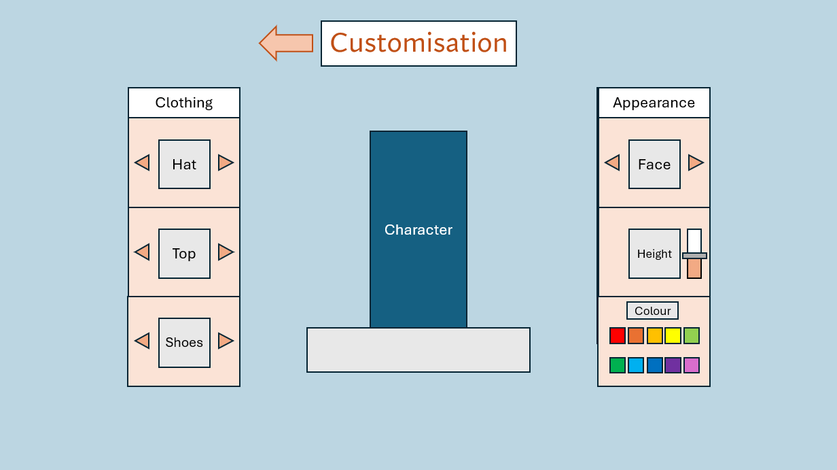
The Customisation page is clearly labelled at the top, I would like to add an icon, like an item of clothing or something similar. The character is located in the middle of the screen, surrounded by windows that can be used to change the design. On the left, it is clearly labelled ‘clothing’ and there are arrows on each component that can be used to cycle along to the next one. This Is the same for the ‘appearance’ window, but the height has a slider. I chose this over something else like a set height/ a few set heights, as it allows the user to fully customize the character. And there are a few select colours to choose from.
Allows the user to cycle along the different options/ change the appearance
Large arrow to indicate that it will take the user back to the main menu.

The level select screen contains a list of the different levels the user has unlocked, in the form of multiple different images in a row. Levels that haven’t been unlocked are hidden behind a lock icon and potentially a blurry image of the level to be unlocked. There are arrows to the left and right of the ‘Play Level’ button, which can be used to scroll along the row. When the level is the one that can be selected, it is larger, indicating it’s the one the user is on.
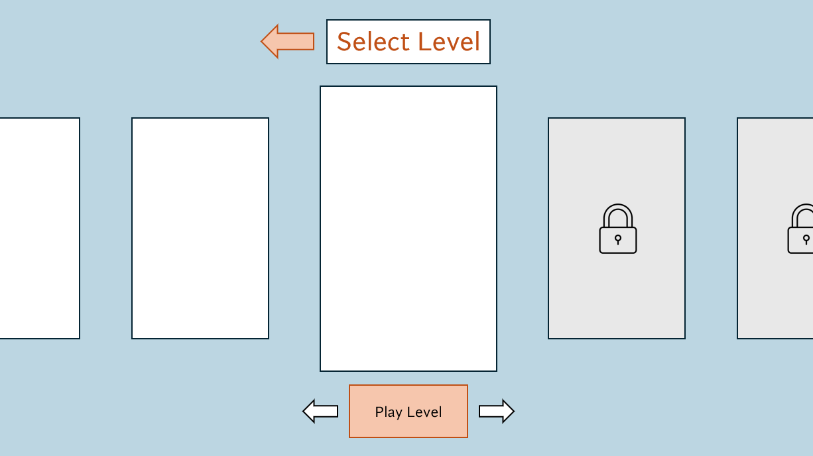
Locked levels have a lock icon covering the image.
Larger level image to show it’s the one selected.
Large arrow to indicate that it will take the user back to the main menu.

Development:

Development Stage 1:
Player:

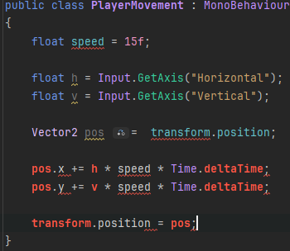
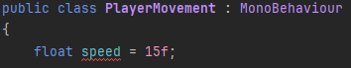
The first thing I wanted to do was make the player move. I started off by creating a variable named speed, which will decide how fast the player moves, I later changed this to moveForce as I think it better describes how it affects the player. At first, I also used the transform function to move the player, which changes the player’s position, but later changed it to directly affect the rigidbody of the player, which is better for physics-based movement which I would like. I also declared variables movementX and movementY, these are the directions that the player will move.

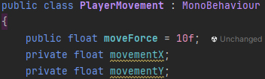

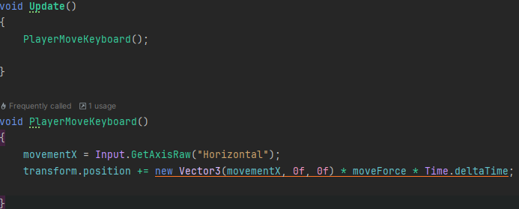
I then made a function which checks what button is pressed on the keyboard in ‘GetAxisRaw’ and adds it to the transform position equation. This multiplies the x position, moveForce and Time.deltaTime to move the player.

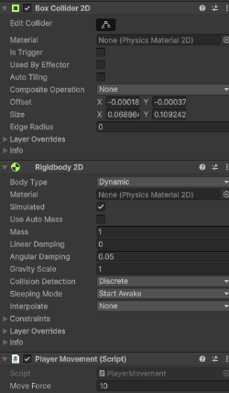
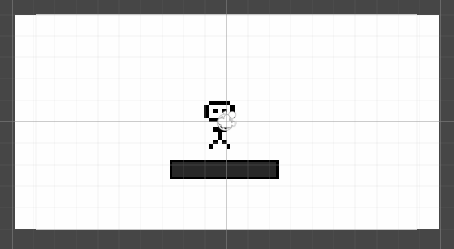
Program was not running. Fixed by changing ‘Active Input Handling’ to ‘both
I added a simple sprite for the player and a platform for it to stand on. The player has a rigidbody, which makes it effected by forces, and a collider that gives it collision and allows it to stand on objects.

Camera:
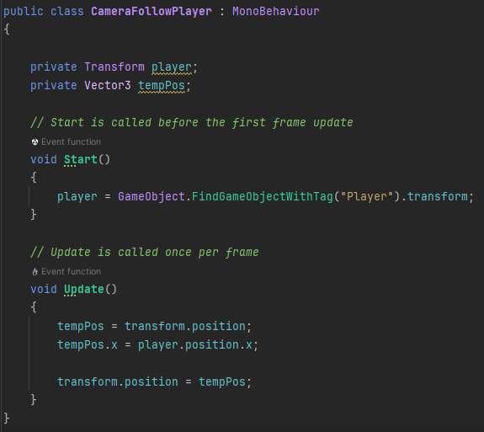
I now wanted the camera to follow the player as it moves, I did this by finding an object with the player tag and changing the x position of the camera to match the player’s. This didn’t work at first and did not follow player. This is because the character is not tagged as ‘Player’ in unity.
So, I fixed it for it to work. Right now, the camera only follows player horizontally, so I added another temporary position which would be the y value of the camera,

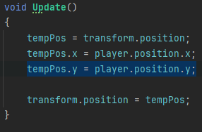

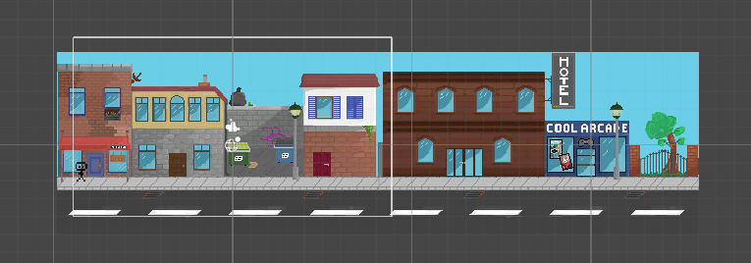
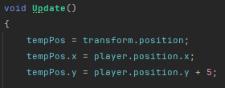
I then added my textures that I had made, of a city street. But the camera wasn’t focused on the street, and you could see behind the side and below the background sprite, which I didn’t want

I added 5 to the position of the camera to see how that would affect it. I then settled on 5/2, being a good number to use as you could see the whole of the scene.

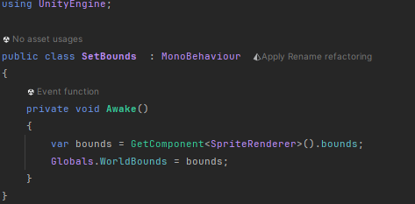
I then wanted the camera the stop when the player reaches the end of the street, I couldn’t figure out how to do this, so I watched a tutorial that (chonk, 2025) showed me how, and then I used what I had learned to code it into my game.
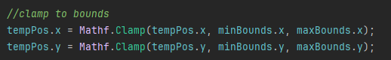
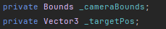
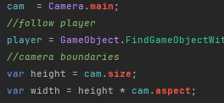

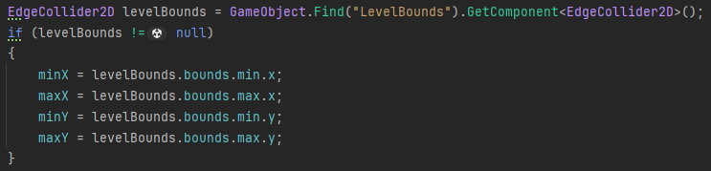
Set bounds of the camera, to an edgecollider which the camera isn’t allowed to pass through.

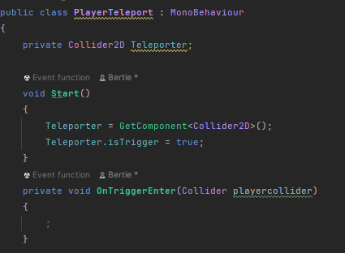

Once that was complete, I moved on to the next part of my development plan, which was crating the way for the player to be teleported, this would be used in the player respawn and to move it between levels, which is helpful as I can reuse it – saving me time.
I started with using a collider component for the teleporter. haven’t added anything to the function yet as I need to add a collider for the player.

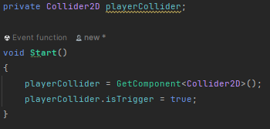
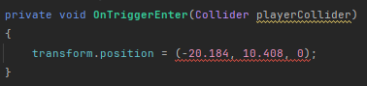
I tried just changing the position of the player when they entered the portal, but that didn’t work. I then added an f after each number to specify a float, with a vector3 object. This came back with no errors

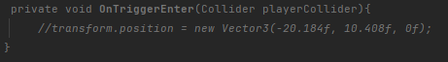
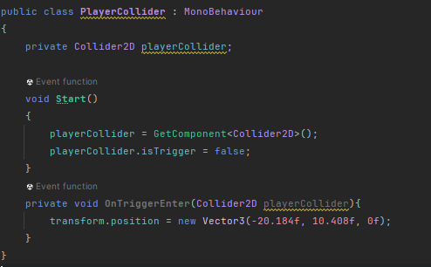
When I started the program, the player kept falling through the floor, I didn’t know if it was a problem with the player or the ground, so I made a new object of a 2d box, the box fell and landed on the ground so I knew it was a problem with the player object.

I temporarily removed the code I had just added and it worked, because the isTrigger box being selected was removing the collision.
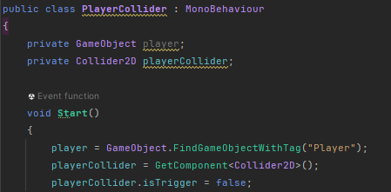
After this, the player wasn’t being teleported, so I created a new object called PlayerCollider which moved with the player and moved the collider code from the player to a new script attached to that object.

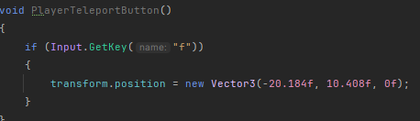
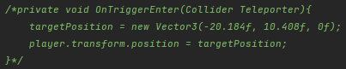
This code ran, but it still didn’t work, so I decided to teleport the player using a button that the player clicks when they get close to the teleporter. I made the previous code a comment. I returned to this problem later as I wanted to continue with the program
I added this function that just checks for when the ‘F’ key is pressed, I chose F as it is close to the WASD and E controls which are used in the game. And this moved the player to the correct position

Then I added a barrier to stop the player falling off the map, but the player could walk through it, so I changed the movement from transform.position to Rigidbody2d.MovePosition. (Unity, 2025)
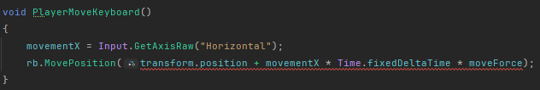
This didn’t work at first, but then I changed movementX to Vector3 and removed the line initializing it as a float. And there were no errors, until I ran the program and there was a continuous error, I didn’t know what was wrong, so I used this site (plbm, 2025) to help me figure out why.
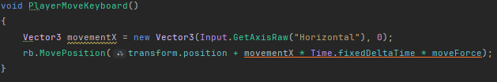

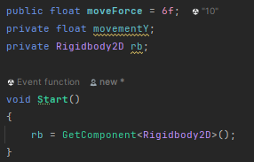
I then added this line inside of the start function which referenced the rigidbody, which applies a force to the rigid body instead of just changing the position with transform. This worked, the player moves and cannot move through the barrier I placed.

I now wanted to make the player jump, as I had sorted out the movement.
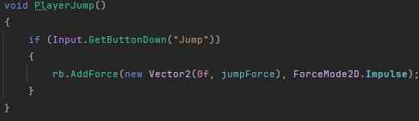
I added a function named PlayerJump to void Update, as that is called every frame, so it will always be checking for a button to be pressed. I added the impulse mode so the force is applied instantly.
This didn’t work at first, as the player didn’t jump when the space bar was pressed. I then changed the input type from GetButtonDown to GetKey and it still didn’t work, as the player only jumped occasionally, and with a lot of force.
I still didn’t know what was wrong so I slightly altered the code again but nothing changed
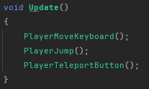
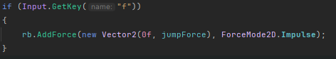

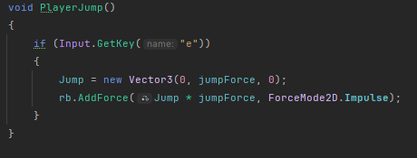

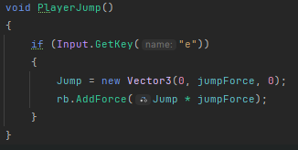
I then removed the Impulse from the line, and the player now jumped but it was quite simple and didn’t work very well, I wanted to add it back in to make it seem more like a proper jump. The player also fell slowly so I increased the gravity scale to about 30, as that seemed to mimic real life gravity more accurately.
I then moved the player jump to FixedUpdate, which is better for physics-based functions than just the Update function. But the player still didn’t jump when the button was pressed.
I then decided to take the inputs for the movement functions in Update rather than in their specific functions, as I thought it may change something.

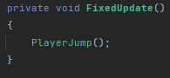
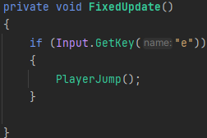
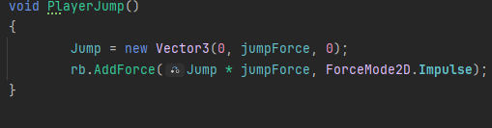
I decided to move on as it still wasn’t jumping, I added 2 functions to see if the player was on the ground and to return true or false, I then edited the jump function to require the player to be touching an object with the ‘Ground’ tag for it to execute the function.

I now focused on making the player jump work properly. First, I added a line that prints ‘JUMP’ whenever the spacebar is pressed, this is to test whether the input is thing not working or something else.
When I pressed space, the word was output into the console, indicating the problem is with the line where the force is added. I noticed that when I teleport the player (apply transform.position) after pressing jump, it gains a lot of momentum. I thought that I could use this and apply transform.position to the rigidbody of the player but not actually change the location. I did this because it could influence the player and make it jump. This didn’t work and the player stayed on the ground. I put another piece of code into the function that I knew worked (the teleport code), and it wasn’t executed when the button was pressed.

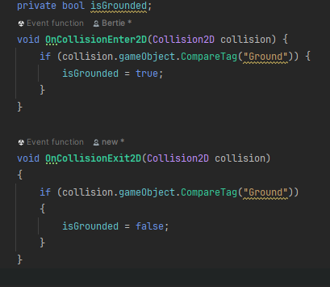
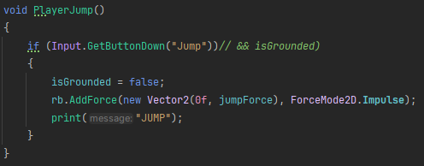
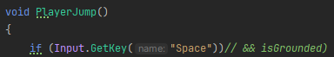
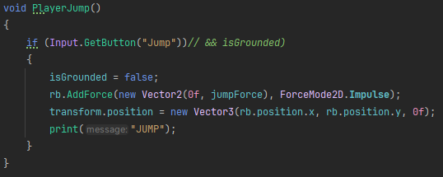
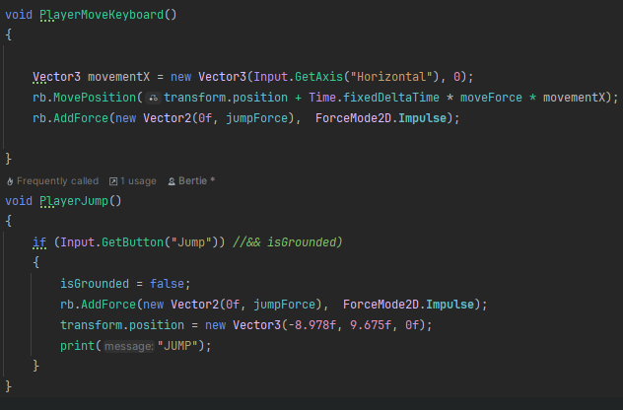
This again, only worked once for the first few seconds, so the player was able to jump one time. To try and fix this issue, I then compared this to other movement code I had written, the only difference was that the horizontal movement was done using transform.position and not applying the force to the rigidbody. I changed my movement code to that, and the player could finally jump. But this is annoying as the player can walk through walls again, as the problem I had previously has now returned. I decided to continue the project and return to this problem at a later stage.
Video: Stage1

I now have no idea what’s wrong. I then removed the addforce line and implemented it into the move function, when the player moved, it also jumped., and when I pressed space, the player successfully teleported. I still had no idea what was wrong. It turns out the function).

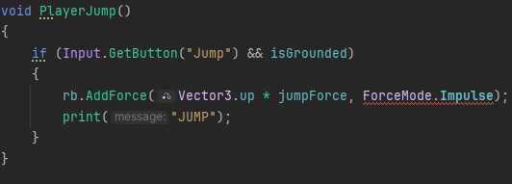
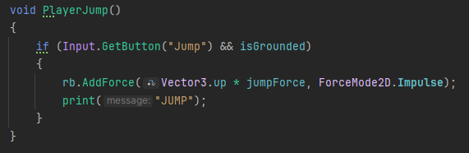

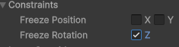

Before I started with stage 2, I wanted to fix a problem that kept appearing with the player, where it was rotating and often falling over, which I didn’t want to happen. This was simple as it required selecting a box in the rigidbody editor.

Test No. | Description | Type of test | Test data | Expected  Result | Actual  Result
1 | Can the  player move? |  | Input  movement button | Player moves | Yes
2 | Does the camera follow the  player? |  | Input movement button | Camera moves with the player | Yes

3 | Can the player interact with  objects? |  | Place player on top of a platform | Player stands on top | yes
4 | Does the player respawn? |  | Move the player off the map | Player is  placed back on its  respawn  point | Yes
5 | Can the player jump? |  | Input the jump button | Player jumps | Yes
6 | Can the player be teleported to the next level |  | Execute teleport function | Player’s position changes to next level | Yes

Development Stage 2:
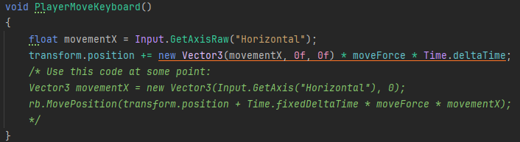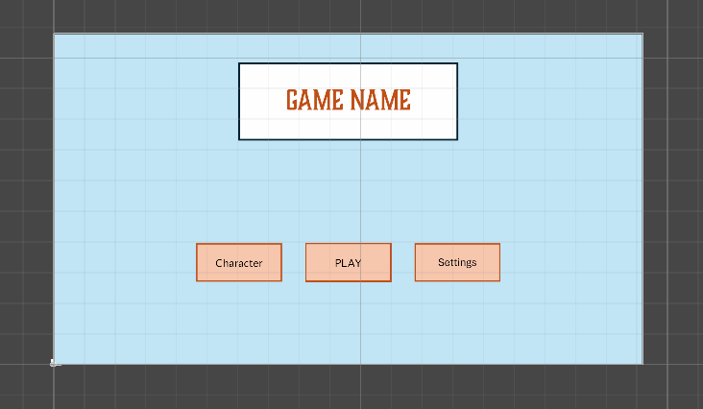

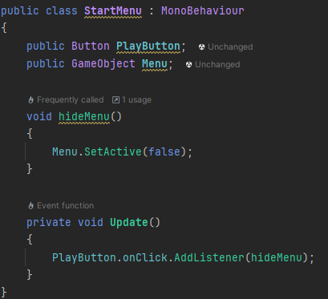
Now that stage 1 was complete, I began with stage 2, where I add a menu screen. At first, I used the GUI design but later I will make a proper one.
I had the idea of just adding sprites that would execute operations when clicked, have the player stand behind the menu screen at first and move position when play was clicked. I realized that was much less efficient and worse than using a canvas, which places the UI elements on screen and allows you to add buttons, which is what I did.
Following the plan for stage 2, I wanted the menu to disappear when the play button was clicked, and for the game to start. This included making sure the player couldn’t move until the Play button was pressed. I added the onclick function for the play button, which will set the menu to inactive, which will hopefully make it disappear. This came back with a NullReferenceException, this was because I had not selected the objects that the PlayButton and Menu objects were supposed to reference. This fixed the problem, and the start button works.

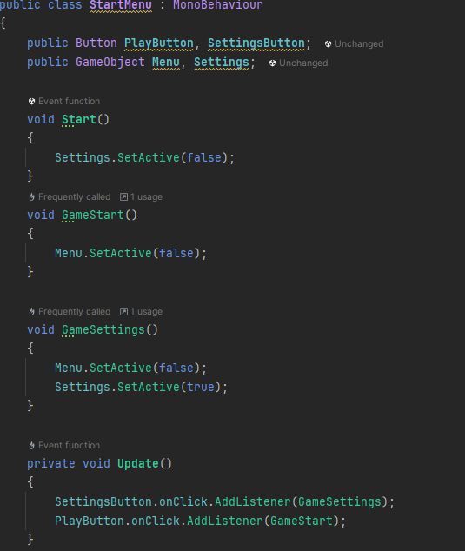
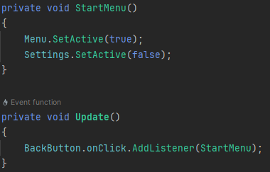
As this was now working, I continue to move through the stage and add the settings menu. This currently won’t do anything as there’s nothing to change now (like key binds and volume), but it will be helpful later in development when I add those things. I changed the function names to make them have a similar naming convention – “GameStart” and “GameSettings” so they are obviously related and part of the same class in the program. This code worked and changed the active panel to settings. But it was slightly transparent for some reason, this was fixed by changing the game object from a panel to an image. The method I have used, where I hide one panel and make another visible, may get confusing and difficult to handle. Because of this, I researched better ways to do this (Unity, 2025) and decided to have each different menu screen in its own canvas, and switch between those instead of having them all in the same one.
In a new class, I repeated what I did for the previous UI panel, but for settings instead. As I had done a lot of repeated code, I decided to make the Settings class inherit from menu, this made sense to me as they are both part of the UI and as I had already declared the classes and objects in the start menu, I didn’t want to repeat that again in the settings one. This all worked as expected, but when the program started, the first panel to appear was the settings menu, when I would like the start screen. As I continued building the UI, a problem occurred where the next panel that I had made wasn’t being set to active. While trying to fix this, I removed the line of code that set the settings panel to false. In doing this, the controls one now appeared.

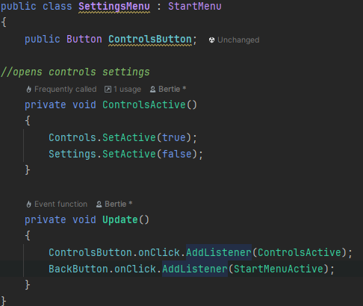
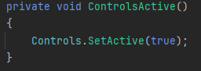
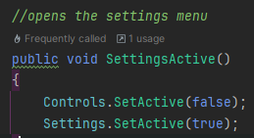
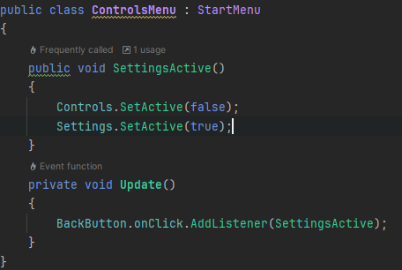
This is the code for the controls menu, where all it has is a button for going back to settings, and a few placeholder buttons for the future when I add functionality to the screen

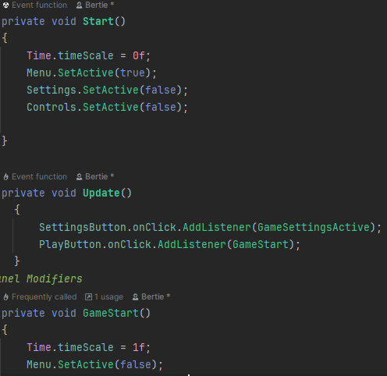
My next task was to pause the game until the ‘Play’ button had been pressed. To do this I used the Time.timeScale = 0 method, this will pause physics and time-based operations. I used this method as it is the simplest one for this game, and right now the only movement is the player, so the only thing being paused would be them. Although when enemies and other moving objects are added, I expect this to also work for them.

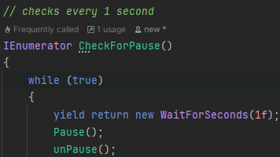
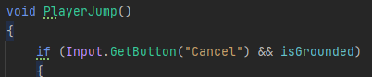
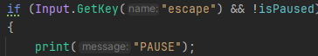
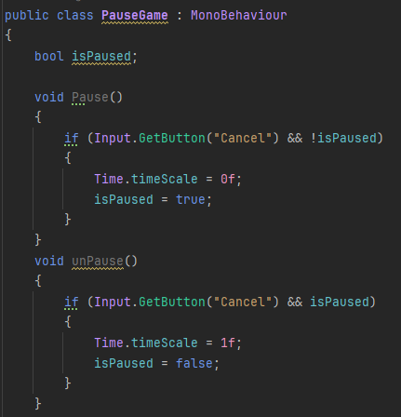
Building on from this, I added a pause button for in-game. I used the timeScale = 0 to stop the player moving when the esc key is pressed. To do this, I created a Boolean to check If the game was paused, which would switch when the game is paused/unpaused. I made use of my previous movement code which makes use of a similar format for checking If the player is on the ground. As this didn’t work, I changed the input method from GetButton to GetKey and printed ‘PAUSE’ into the console to check if the function was executing. I did this because I had done it previously to fix the jump code, and it worked well. This was helpful as when I pressed escape, nothing was printed, helping me pinpoint the location of the error. To check that the input function was working, I changed the jump input to escape. I did this as I know this piece of code works properly and will tell me if I’m using the correct input for the pause function, when I started the program, the player jumped when I pressed escape, this helped me discover that the reason for it not working is because I hadn’t actually put the script into the scene, so it wasn’t active. I also realized that this function was executed many times a second. To fix this, I decided to use coroutines that check every 1 second for an input to pause the game, this will make it harder to accidentally pause and unpause. While doing this, I decided to add the GUI for the pause menu, containing the buttons to leave the game and enter settings.
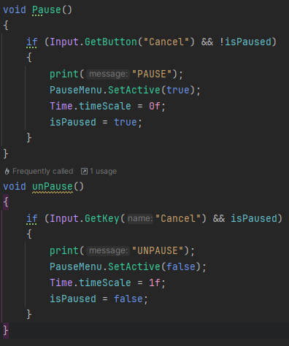
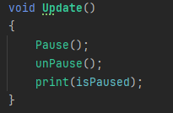
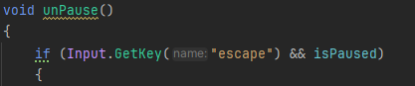
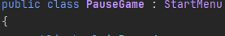
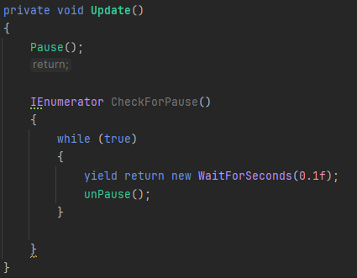
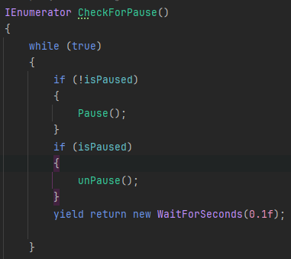
The two functions were still happening at the same time, so I separated them into if statements to see if that would cause one to happen, only after the other one has. Another way I chose, was to have the unpause function in the coroutine and have the pause in the update function, this will cause unpause to execute 0.1 second after the pause function, so they happen at different times. This didn’t work as I had the check function inside the update one, so the StartCoroutine method wasn’t able to access it, I reverted the code to its previous form and the game successfully paused when I pressed ESC but was unable to unpause. I Decided to add the menu UI and return to the problem later, as it would appear when the game is paused, I changed the PauseGame class to inherit from StartMenu, I did this because I would be using objects that I had already declared in StartMenu, saving me time. Once that was completed, I realized there was a disparity between the inputs being taken for pause as one was ‘’Cancel’’ and the other was ‘’escape’’, I decided to change the GetKey function in unpause to take Cancel as that was working correctly for the Pause subroutine. Fortunately, the pause menu did appear, but the Pause Boolean was not being set to true, and continuously stayed false, meaning that it just paused the game again whenever the escape key was pressed. To fix this, I temporarily removed the coroutine, and added both the functions to Update(), this was to check if it would work without the coroutine, as it didn’t seem to be working. I also added a line that prints the isPaused Boolean into the console, this reason for this is to check if the variable is being changed when the escape key is pressed, helping to find the point where the error occurs. I also realized that I needed to change ‘GetKey’ to ‘GetButton’ as the ‘Cancel’ input key is not known and should be GetButton for it to be recognized. This caused the previous problem to occur again, where both inputs happen at the same time, stopping the program from pausing properly.

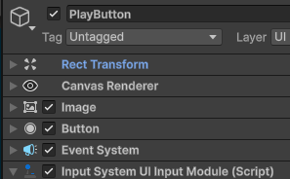
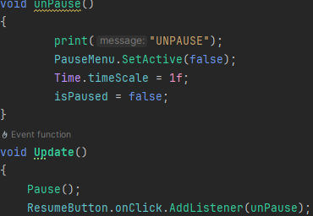
As this was taking too long, I decided that I would return to this problem and change the button to unpause the game to be the resume button that appears in the pause menu, as this can’t be pressed at the same time as the escape key, while simultaneously removing the chance of accidentally pausing and unpausing by pressing it too many times. I did this by adding an onClick function to the resume button which calls the unpause subroutine when clicked. During this, the play button stopped working, this required adding the ‘Input System Input Module’ component to fix the problem (Stack Overflow, 25). Once this was complete, the game now successfully paused and resumed.
Video: Stage 2
With this, the second stage is now complete as I have completed everything I set out to do in the development plan and can move on to stage 3.

Test No. | Description | Type of test | Test data | Expected  Result | Actual Result
1 | Does the game start? |  | Press the start button | Scene, and sprites  appear | Yes
2 | Does a  pause menu appear? |  | Press the pause  button | Pause menu appears | Yes
3 | Game stops when paused |  | Press the pause button | Game objects stop moving | Yes
4 | Can you navigate the start menu? |  | Click each button in the UI | Pages switch when the buttons are pressed | Yes
5 | Can the start menu be used to change the controls and volume? |  | Click the respective buttons | The user is able to change that setting. | No

Development Stage 3:
As I am focusing on creating movement mechanics for the game, the first task I wanted to complete for the third stage was fixing the movement in general, as it is laggy and the player can walk partly through walls, which I didn’t want. Originally I fixed this by adding momentum to the player object’s rigidbody component. But this added extra problems with being able to jump, which I aim to fix.
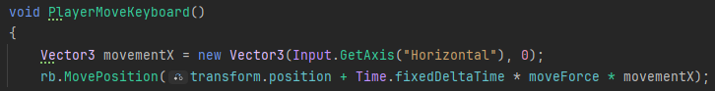

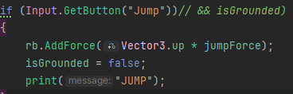
I removed the temporary code and replaced it with the original physics-based movement. This allowed the player to move properly but it could no longer jump using the current code. To help with making the player jump, I temporarily removed the isGrounded Boolean from the if statement as it is one less variable to worry about in case there’s an error or something stops working. Once I had done that, the player object moved up when the spacebar was pressed. I then added an impulse that would hopefully make the player jump instead of just slowly moving upwards, this didn’t work and the player stopped moving. I then decided to change the vector type from 3 to 2, but this didn’t change much. I then decided to add the exact amount of force to jump to a specific height. (HowToJumpInUnity, 25). As this was happening many times a second when the spacebar was pressed, I added the jump function into FixedUpdate, which checks fewer times per second, this is helpful as it means there’s less of a chance of the player jumping twice while the spacebar is only pressed once.

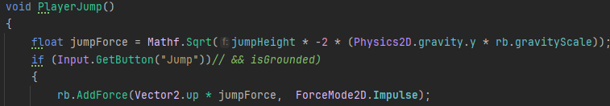

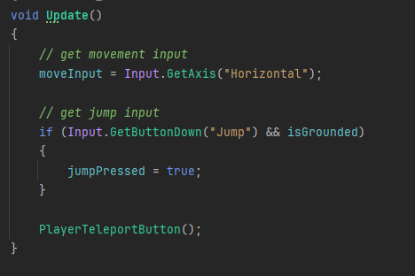
As the player was still not jumping, I decided to separate the check for an input and physics-based operations into the update() and fixedUpdate() functions respectively, as fixed is mainly for physics and I currently had the jump inputs included within, I felt as if this was a reason for the player not jumping properly. Using jump pressed variable in update, and if statement in fixed update
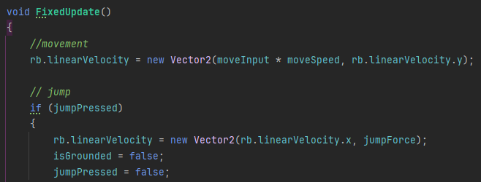

Create double jump
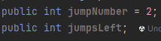
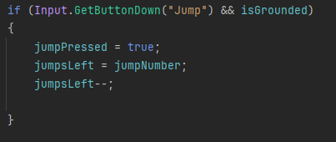
originally in update( if statement)
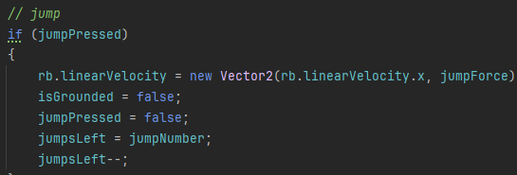
moved to the fixed update. Stopped player from jumping. jumpsLeft was never being reset

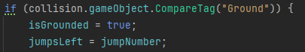
reset jumpsLeft to 2 when the player is touching the ground. As the player can only jump twice before not being able to anymore
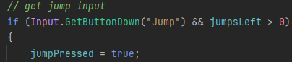
still didn’t jump as it was still checking for grounded. Removed. And the double jump worked properly.

Moved on to create the grappling hook, added a placeholder grappling hook that the player could hold. At first, I thought I could attach the player movement script to it and have them move together, but that didn’t work.
(Unity, 2025)
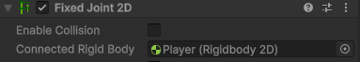
I then used the fixed joint component to connect the player and the grappling hook

I wanted to have the tool point towards the player’s mouse cursor.
(Brackeys, 2025) – this video on top-down shooting provides code that makes the player look at the mouse position. I watched that section of the video and used the in-built functions I had learned to add it to my program.

The next thing I wanted was to move the rope to where the mouse was located. Idea is to use a raycast to hit the location in the direction of the mouse. And a line renderer to draw the rope (Unity docs, 2025)
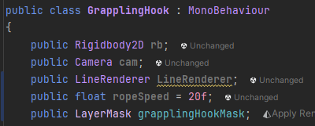

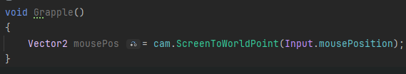
Utilizing screentoworldpoint

casts ray
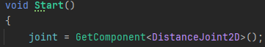
to check if a raycast has collided with something (Unity Discussion, 2025)

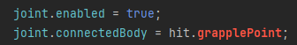
needed a vector, wrote grapplePoint as a placeholder. Changed connected body to connected anchor as it’s a pivot that allows the joint to rotate which is what I want.

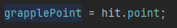
vector is equal to where the ray cast has hit a collider
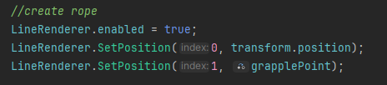
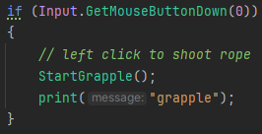
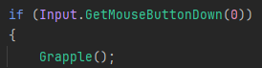
creates a rope that moves from the original position to the grapplepoint. Once this was finished, no line was created. This was because the grapple function wasn’t being called when the mouse button was clicked. Still didn’t work, as Rope wasn’t being updated. Still wasn’t working so I added a print
line to Update() but nothing happened. Script wasn’t referencing the object oops. Still wasn’t working when left click
created function called update rope. Added print to the left click to indicate if it was being called.
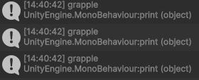
indicates that the problem is elsewhere.

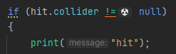
indicates what happens when the raycast hits/misses
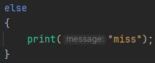
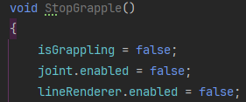
the line for the raycast wasn’t being drawn, but I was able to fix the raycast not hitting anything by changing the grapple mask from nothing to default. The effects of this were showing as the player was able to hang from an object above. Player wasn’t able to put grappling hook away FIX THIS.
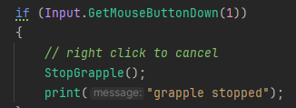
Right click disables the joint connection with the object so the player is released.

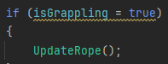
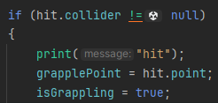
Grappling hook was hitting playercollider. Removed player collider. Was now also hitting player, to fix this, I put the player onto a different layer named ‘player’ that the raycast wasn’t able to hit, the grapple was now able to attach to other objects but the swing radius was too wide. Also, the line renderer wasn’t constantly updating to follow the player to rectify this problem, I set a Boolean named ‘isGrappling’ to true when the grapple starts, and to false when it stops. This is then called in Update() to make sure that it follows the player.
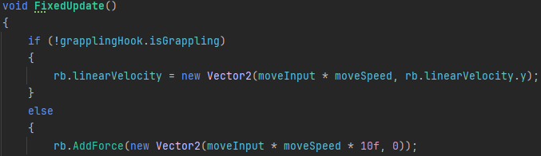
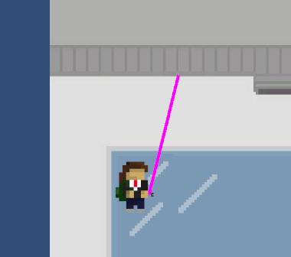
The grappling hook now works.

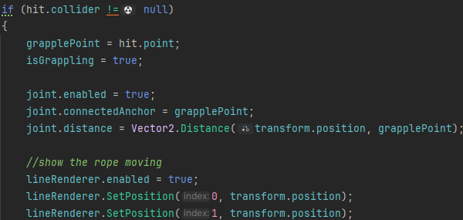
Player loses speed at turning point of the swing. The cause of this problem is movement code overriding the horizontal velocity. To fix this, I wanted to add a small force to the player when the swing is at its lowest and stop the player movement code from being called when the player is grappling. Player stopped moving. Set isGrappling to false on game start

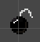

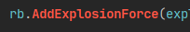
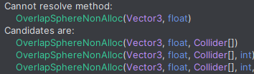
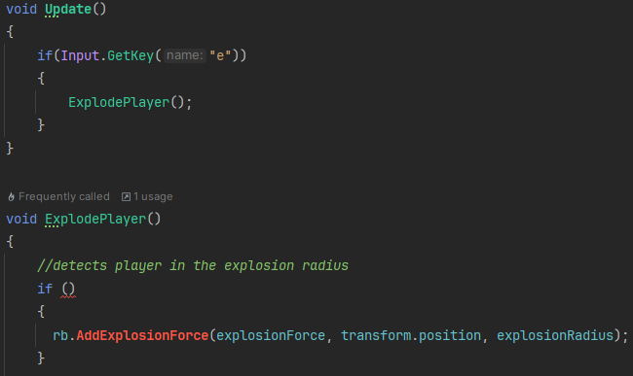
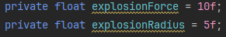
Creating explosion to help the player move. Needed a way to propel the player. Unity has an AddExplosionForce, which I can use to add a force to the player from the bomb. At the moment, I would call the function ExplodePlayer when the ‘e’ key was pressed. Temporary for testing. Want to detect player to see if a force should be applied. Stuck so looked it up. Used tutorial from (gamedevbeginner, 2025) but it was on how to apply the force to multiple colliders when I only wanted to apply it to the player, makes it simpler for player. Can use layer mask to choose what layers it applies to. Needed to use Collider[] array as a parameter.
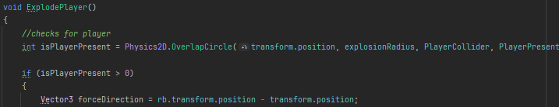
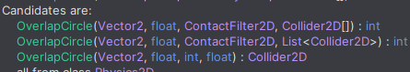
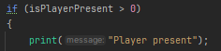
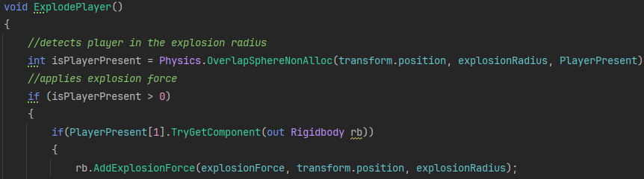
Couldn’t resolve. Try to fix, works with out Rigidbody rb in the if statement. Debugging, print the isPlayerPresent attribute. Doesn’t appear in console so player isn’t being detected. AddExplosionForce and the overlap sphere (should have been obvious as it has sphere in the name) is only for 3d objects, so the code wont work. Need to change a few things. Collider Collider2D OverlapSphere OverlapCircle, which needs a contact filter 2d. AddExplosionForce is now forceDirection = rb.transform.position -transform.position. Code is now able to work with 2d.

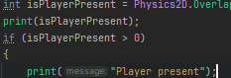

Test to see if working

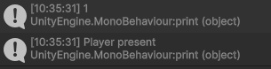
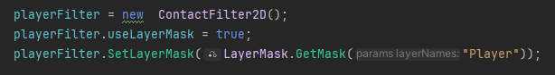
It says player detected but force is not applied. Think it’s because its just detecting any rigidbody as even when the player is out of the radius the player present message is still printed. This is because the contact filter layer mask wasn’t configured to only detect the player. Fixed and the player detected. Force not being applied – maybe being applied to the bomb and not the player. Using the playerPresent array, as it contains the players rigidbody, apply the force to the attached rigidbody. Force successfully applied and the player moved away from the bomb.

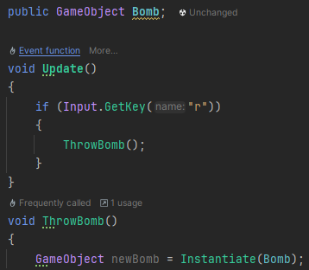
As I wanted the player to make the bomb appear, I now needed to spawn a clone of the bomb when the use button is pressed. This starts with making a prefab of the bomb and then using instantiate to spawn it on the map.
Bombs successfully spawned but too many, so I added a delay in the if statement of a few seconds, at first I wanted to use WaitForSeconds() but it required the use of coroutines, which would take too long. So I used a simple timer that counts up but resets to 0 when the SpawnBomb is executed.

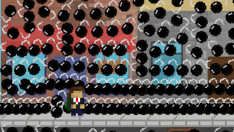

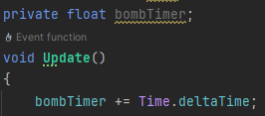

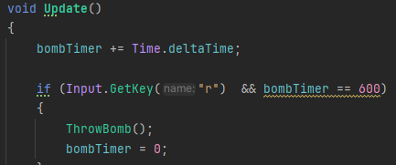
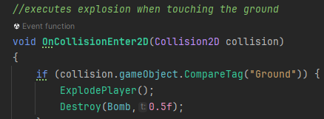
was being set equal to 600 when it needs to be larger than. 600 too high. Set to 2. The object was no longer created every frame. Now as it was exploding, I wanted to destroy the object on execution and detonate when it touches the ground. For this I will reuse my player movement code that already checks if the object is touching the ground. Object permanently destroyed and could not make a new clone 0. Moved bomb to ExplodePlayer() function. Now being destroyed instantly, no force being applied to the player. Now it waits 1.5 seconds before being destroyed
This code executes the explosion when the bomb is touching the ground. Bomb was destroyed but the ExplodePlayer function is much weaker, set the force to 3,000 and the bomb works properly now.
1 | Can the player double  jump? |  | Press space twice | Player can jump | Yes
2 | Can the rope attach to the  Ceiling? |  | Touch the two objects | Rope  attaches to the object | Yes
3 | Can the player fire the rope? |  | Press the action button for the rope | Rope moves until it reaches an object | Yes
4 | Can the player swing on the rope |  | Move around when rope attached to the ceiling | Rope attaches to the player, allowing them to swing | Yes
5 | Can the player throw a bomb |  | Execute function to throw. | Bomb object is created | Yes
6 | Does the bomb propel the player? |  | Press the action button for the bomb | Moves the player away from the bomb | Yes

Development Stage 4:
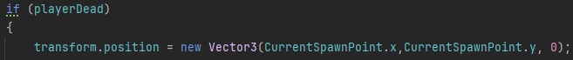
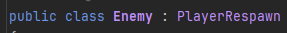
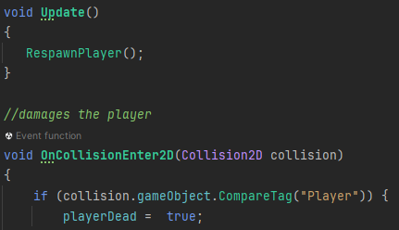
This development stage is for creating enemies that the player must avoid/fight to complete the level. Before I create a specific one, I will make a class called ‘Enemy’ that all the proceeding enemy classes will inherit from, this makes it faster and easier to code things that they will all have in common, like dealing damage to the player. A simple way I tried at first was to check if the player is touching, and kill/damage them if that is true. I also made it inherit from the PlayerRespawn class as it contains the player respawn function and player death Boolean which will be helpful for executing the function when the player touches the enemy. This teleported the enemy object when touching the player, which I didn’t want. The reason for this is that I wasn’t specifying which object to teleport, so the position of the enemy was being changed. The first thing I tried was just put the player rigidbody in front, but this came back with errors. I then changed the PlayerSpawnPoint variable to just be playerRB.position.x or y and the playerRB.position vector containing the player’s spawn point variable. This didn’t work and still changed the position of the player. I was still setting the location of the spike with transform position; I reverted all the changes I made and added playerRB.transform.position to the playerDead if statement, the player’s position was now reset when touching an enemy.
Now the enemy parent class was complete, I could move on. First one was spikes, very simple only needed to use the parent class as I wasn’t adding anything. Based on the development plan, I needed to make a character that would attack the player, a good second addition that would fit the theme of the first level, is a turret that looks towards the player and fires projectiles, as it’s the first level I want it to be easier, so I will add some randomness to where the turret fires, but still in the general direction of the player. It will have a stand that stays in one position and a gun on top that aims towards the player.
I first referenced the player object that the turret will be looking towards. After this I didn’t know where to start, I thought that I could make use of Unity’s lookAt function, but that’s only for 3d. I looked it up and you can make use of quaternions to represent a rotation using 4 numbers, and quaternion.lookrotation where you can pass in values of where the object should point.(Unity Discussions, 25)

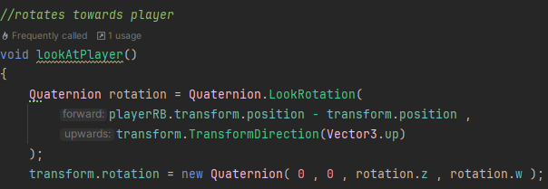
I used this piece of code to start off with, and I will add things to it like only doing it within a certain distance of the player and refining the directions. This worked well and pointed towards the player, but the wrong part was pointing to it, in order to correct this I flipped the sprite and it looks better, but I may need to do a more robust fix when firing projectiles, as they need to be fired from the correct place. My first thought for this would to have a small object attached to the front of the turret, that the bullets would fire from, as it would always shoot from the place pointing at the player object. I attached it to the turret using the fixedjoint2D component, which needed a rigidbody. The object didn’t move with the rotation of the gun. The next idea was to instantiate an object at a specific point on the turret sprite, but I didn’t know how to do this. I realized that I might not need to that and could just place it in the centre of the object and create the illusion that they are coming out the front as they are both pointing towards the player. I created an empty object named ‘shooter’ that the turret head will instantiate the bullet objects on, these will then proceed to move towards the player.
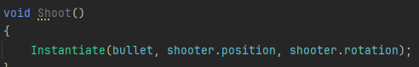
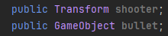
I started by referencing the objects that will be used in the code and instantiating a bullet in the same location and rotation of shooter, this is part of the Shoot function. Which is being called in Update.
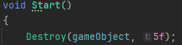
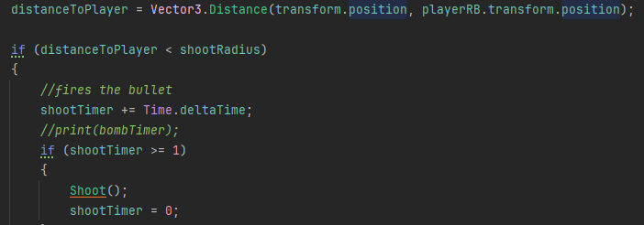
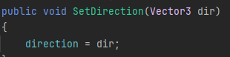
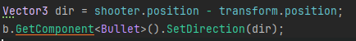
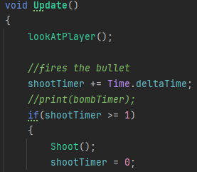
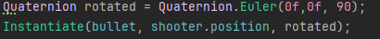
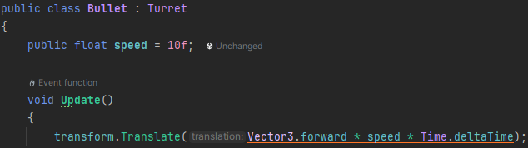
I then wrote the bullet class, which just moves forwards, I reused my old movement code which makes use of transform to move the player. As the bullets weren’t rotating, I altered the code to have the rotation be in terms of the turret. This still didn’t work and the objects stayed perpendicular to the rotation that I wanted, I tried rotating it by 90 degrees in the sprite editor, but it still didn’t change. I then tried to change it in code, using a quaternion to specify the rotation. This always kept the z rotation at 90, so I added it to the original shooter rotation but this didn’t work and nothing changed. The bullet also wasn’t moving, I thought this could be as it was inheriting from the turret, and that the turret’s Update() was overriding the bullet Update(), this didn’t work and the object still didn’t move. I then changed Vector3.forward to Vector3.up and they now moved, but only in 1 direction. As they were being called every frame, the game started running slowly after only a few seconds. To prevent this, I wanted to add a delay between each one. For this, I reused my timer code that I had made when coding the SpawnBomb class. I then destroyed the game object after 5 seconds. Once that was complete, I tried changing the direction of the bullet when it was instantiated, where that would be the direction it moves. It works by setting the direction of the bullet using the SetDirection function that is in the bullet class and getting it in the turret class, where it sets the direction of the object. They now move and rotate towards the player’s position. to fix as unity suggested normalizing the dir variable, this worked and the bullet didn’t change its speed. This part was now finished mostly, but the player would be fired at from far away. To prevent this, I will use a Vector3 that checks the distance to the player and compares it to the shooting range, once the distance from the player is less, the turret starts to fire.

Test No. | Description | Type of test | Test data | Expected  Result | Actual  Result
1 | Do the enemies try to attack the player? |  | Move player towards enemy. | Enemies aggress towards the player, once they get close enough | Yes
2 | When hit by an attack, does the player take damage/get reset? |  | Player touches component that damages them | Teleported to the beginning of the screen | Yes
3 | Do the enemies take damage from the player’s attacks? |  | Enemy touches player attack. | Enemy takes damage/ disappears. | No
4 | Is the player able to attack? |  | Press attack key | Player attacks | Yes

Development Stage 5:
The player will spawn into an intro level, with no abilities apart from moving left to right unlocked, then they will arrive at a building they are able to enter. This is level 1, introduce double jump and first enemy. Second part introduce bomb and second enemy, 3rd part introduce grappling hook and 3rd enemy. Added semisolid (Unity, 2025)

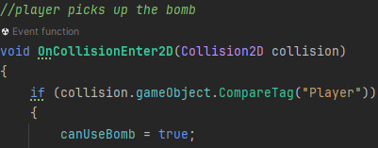
picks up bomb

Same for grapple:
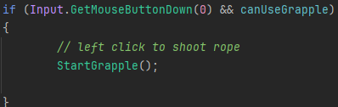

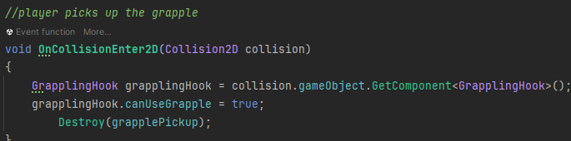

Test No. | Description | Type of test | Test data | Expected  Result | Actual  Result
1 | Is the player able to complete each level? |  | Player attempts to complete level | It is possible to reach the end of the level | Yes
2 | Does the player receive a new tool at the end of a level? |  | Execute function to give the player a new tool | Player receives it in the tool slot. | Yes
3 | Does an image appear to display the unlocked tool to the player. |  | Execute function to give the player a new tool | Image appears, showing the new tool. | Yes

Development Stage 6:
required brackets

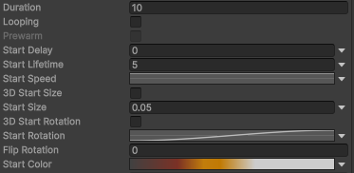

Gradient of grey to red to yellow to white, imitates an explosion

Bomb was visible after the explosion was over and during it or, the particle animation stopped when the object was destroyed. To fix this, I originally wanted to make the rigidbody kinematic, as I thought this would prevent it from being visible and non-movable, as this didn’t work, I disabled the sprite renderer for the bomb object, making it no longer visible and the animation was able to carry out properly.

Animations for player:
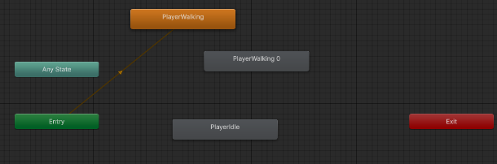
used tutorial by (Brackeys, 2025)

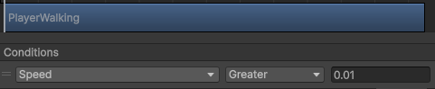

if it needs to be flipped, rotates 180 degrees on y axis, only 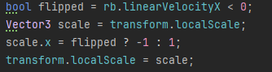worked for a few frames, as flipping 180 degrees conflicted with the player walk animation, but when the x axis is scaled by 1 or -1, the animation is not interfered with.

1 | Does an animation play when the enemies move? |  | Move the enemy | Movement animation plays | No
2 | Does an animation play while the enemy is attacking? |  | Execute enemy attack function | Attack animation plays | No
3 | Does an animation play when the player moves? |  | Press the player movement key | Player animation plays | Yes
4 | Does an animation play when the player attacks? |  | Press the player attack key | Attack animation plays | No
5 | Do simple animations play when clicking buttons in the UI |  | Hover mouse over button | Subtle colour change to show selected button | Yes
5 | Do simple transition animations play when navigating the UI |  | Click button to change between screens | Transition animation plays to make | No
6 | Does the Controls menu work |  | Press buttons to change key binds. | Menu appears to change key | Yes
7 | Do sounds play when certain actions happen like a player death/  explosion |  | Execute function that causes the sound. | Noise plays. | No
8 | Does an animation play when the player dies? |  | Respawn the player | Transition animation plays so respawn is seamless. | No

Code That Has Been Returned To:
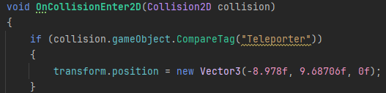
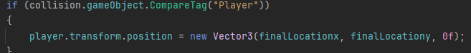
When creating the teleport code to move the player between levels, I didn’t know how to check if the player was colliding with another object. After creating the player jump, where it checks for a collision with the ground, I could now reuse this code to quickly and easily make the teleporter work as intended. As I will have multiple teleporters, I’ll use a public x and y variable that I can change in unity for where I want the player to teleport to. Didn’t work as the teleporter was looking for something tagged with ‘teleporter’ when it should have been looking for ‘player’

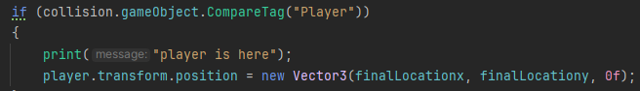
Also added a check to see if the player was colliding with the teleporter. Player isn’t being detected by the teleporter. The problem was the teleporter was being set as a trigger, which do not fire collision events.

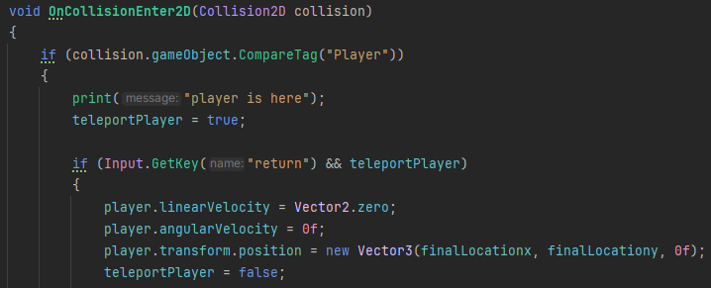
teleport when enter is pressed
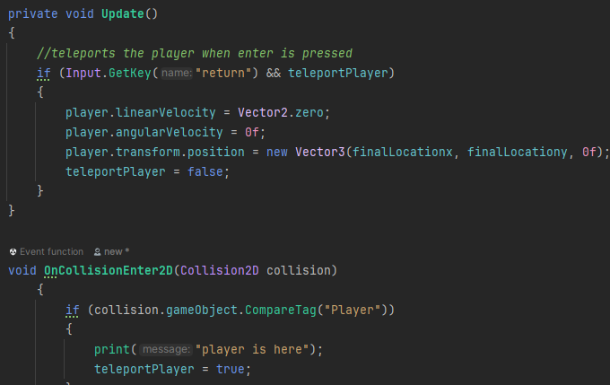

Input doesn’t work inside of collision

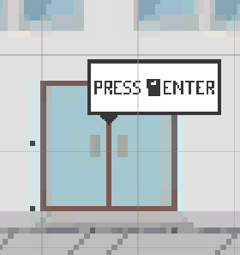
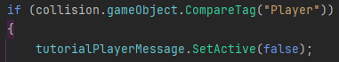

Disappears when leaving

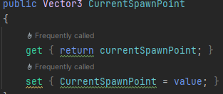
Write a getter and setter for currentspawnpoint, reference it in playerteleport class.

End Testing:

My Survey:
Bosh - 2D Platformer Beta Testing Form – Fill in form

My beta testing will include sharing my program plus the survey with a wide range of people in order to get a consensus on each different component of the game. If they do not have a computer to run it, I will provide one for them to play on. The questions in the survey will cover each individual part that I have coded, like the movement, enemies, tools, level design and aesthetics. On top of this, I have added a section asking what should be added if I continue to develop the game.
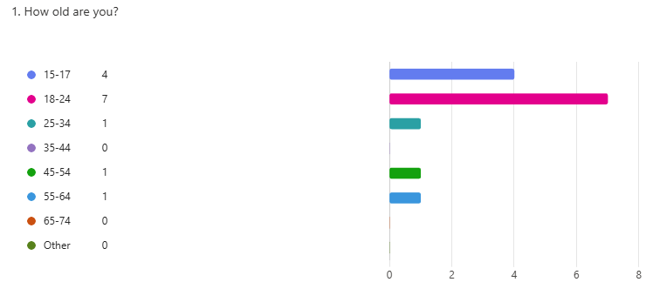
- This indicates the average age of the user taking the survey. The majority are from 15-24 but there are a few from 45-55 which allows me to see a different viewpoint
on the game.

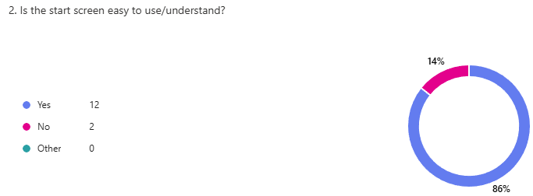
- The first question about the game is on the ease-of-use of the opening screen, this is important as it’s the user’s first impression of the game. Thankfully. 86% of the users answered yes to it being easy to use. This indicates that the buttons are labelled well and work as intended.

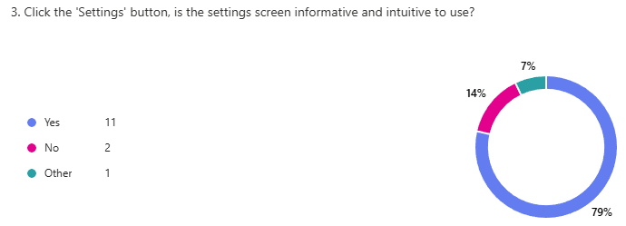
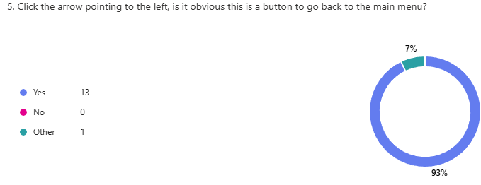
- Continuing with the ease-of-use theme, the next question asks the users if the setting screen is easy to use, with 11 people answering yes and one answering ‘kinda’, this indicates the settings screen is designed well. This is backed up by a question asking about the back arrow in the settings with 13/14 answers saying the use is obvious and 1 responding with ‘it is hard to see’, this implies that I should change the colour to stand out more.

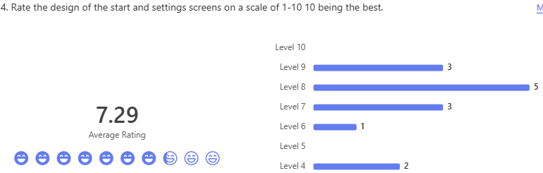
- The next question asks the users to rate the design of the menus. The score received was a 7.29/10, this indicates that its good so far but could use improvement.

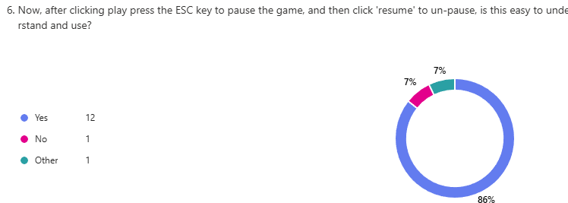
- The final question to do with the usability of the menus is to do with the in-game menu, where 12/14 people responded with it being easy to use and understand.

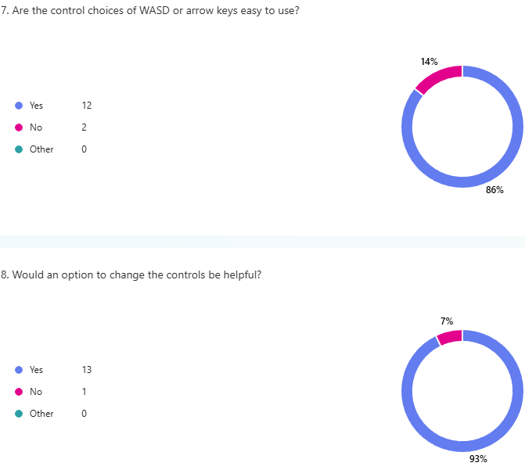
- The next questions are to do with the usability of the character movement. These 2 consecutive questions ask about the controls , with 12/14 people saying that the default ones of WASD/arrow keys are fine and easy to use. But 13/14 answer yes to being able to change them, indicating this is an important feature that’s integral to the user experience of the game

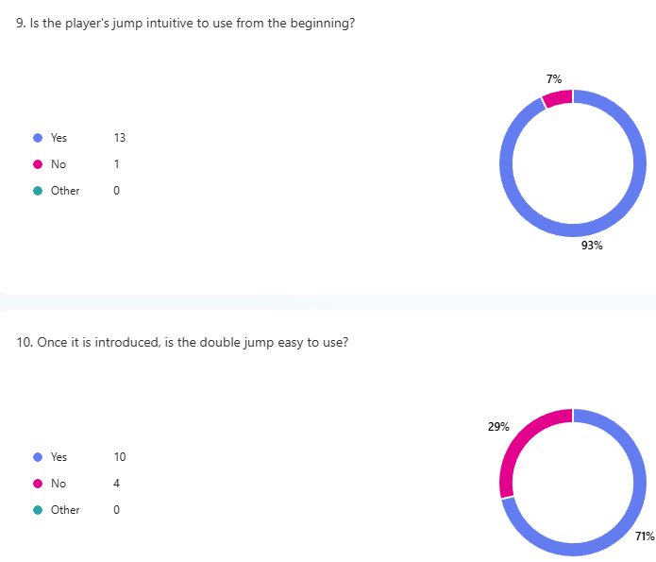

Robustness Testing:

Test 1:
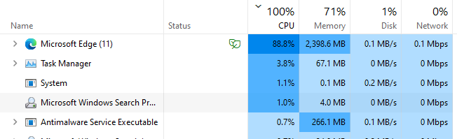
To test how the game functions under different conditions, I opened a large number of Microsoft edge tabs to increase the CPU and memory usage, I then ran the game to see how it was affected. My expected result for this is that the game will run more slowly and the player’s relative speed and jump height will potentially change. Once started, it ran normally as the way the physics-based objects worked didn’t change. But it ran more slowly as the computer itself was running slowly. -show evidence of program using CPU- . Overall, this is a pass, because even though the computer was running very slowly, the program was still able to carry out calculations and perform in a similar way, albeit at a lower frames per second.

Test 2:
For the second test, I input a large volume of key presses while the game is running, this is to see how the game functions when it is receiving lots of inputs. My expectation is that the game will run as normal and nothing would happen within the program. Once running, I carried out the test, and nothing happened. Thus, this is a pass, as the game wasn’t affected.
Test 3:
Laptop with i5-8365U

Evaluation:

Success Criteria:

Ranked from Met to Partially Met to Not Met

Menu Features:
Feature | Importance | Rank | Explanation
Opening screen of the program displaying the name of the game and buttons available to press. |  | Met | This criterion was met almost exactly. When the game is opened, the title screen appears, plus the buttons for settings, start and character can be seen below it. The only unfinished part is from the (GUI Design) where I wanted the background to be slightly transparent, which images of scenes from the game in the background. As this wasn’t a high priority task compared to the other components of the game, it wasn’t completed. The background was kept as a light blue colour.  Stage 2.mp4 00:00
A button that can be pressed taking the user to the game settings. |  | Met | This feature was also met to a good standard; the settings button is labelled clearly and takes the user to the settings menu once pressed. The button changes colour when the mouse hovers over it to indicate it can be clicked on. Although it works, an error can occur where it requires multiple presses to work as intended, this is seen in page X where the error first occurs.  Stage 2.mp4 00:00
A working settings menu, that allows the user to change the volume, and the controls to what they prefer. |  | Not Met | Within the settings menu, although I did plan to have working buttons and sliders for volume and controls (Stage 2), this became non-essential during development and I prioritized other components of the program that were of higher importance. But I did add a button to open the controls menu, evident in page X of the development. This did work somewhat but took the player to the menu screen when it is first clicked. This is an error that I wasn’t able to correct. In further development, this wouldn’t be too hard to correct, it would involve changing the inputs the game takes to variables, which could be altered in a menu to what the user would like.  Stage 2.mp4 00:05 - menus
A button that will take the user to whatever level they were on when they last played. |  | Partially Met | This piece of criteria has been ranked as partially met. When the play button is clicked, the user is taken to the first level every time. Instead of being able to choose which one. Creation of the play button is shown on Page X of the development. But the rest would have taken too long and reduced the quality of other components in the program, so it wasn’t completed. In further development, once more levels are complete, I can add buttons that change the player’s position to a certain level, by changing its spawn point.  Stage 2.mp4 00:15 – play button
A menu that can be opened using a button that lets to change settings/exit to menu while in game. |  | Partially Met | This feature has been marked as partially met due to not being fully complete. A requirement for this feature, indicated in Stage 2 is that the game also stops when the pause menu opens. This was implemented and works as intended, there are buttons that also appear, that are supposed to resume, open settings and exit. Development page X. Only one of these works – the resume button – and it allows the player to continue playing the game. The other two buttons have been left out due not being essential for the user’s experience of the game. As the only thing you can do in the menu is start the game, returning there isn’t necessary, so I didn’t implement it.  Stage 2.mp4 00:17 – pause menu
A shop where you can buy cosmetic items for your character. |  | Not Met | This was tagged as optional in the analysis of the project, as it was an unnecessary feature to add. Although it would have been welcome, as shown by the stakeholder survey where 16/18 people responded ‘yes’ to customising their character. Despite this, other more important features were prioritised and this wasn’t implemented. If I were to continue development, this would be hard to carry out but would involve storing different sprite designs and changing them based on what the player has selected.

Gameplay Features:
Feature | Importance | Rank | Explanation
The ability to move the player around and have them jump/duck plus another extra way of moving to add to the gameplay e.g. a double jump. |  | Met | This feature has been met very well, originally the player’s movement was weird and contained many bugs like being able to move through walls. Development Page X. But I improved it and now it works with many less errors. Development Page X . This component has been fully completed and works as intended.  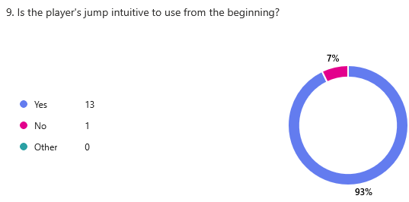  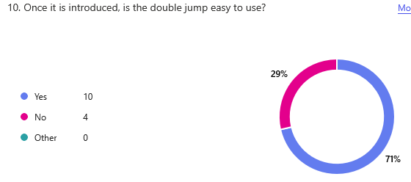  Stage 1.mp4 00:01 – moving + jumping  Stage 3.mp4 00:10 – double jumping
Extra abilities that are given to the player to allow them to dash or jump higher or propel themselves off in a certain direction. | Very desirable | Met | The criteria for this feature have been met to a good standard, the development plan for Stage 3 was to create a bomb that could propel the player, and a grappling hook with which the player could use to swing. Both of these have been created. A small problem with the grappling hook is that it isn’t very easy to swing, this is evidenced in the stakeholder survey where 11/14 answers claimed that it was hard to use. A fix for this which I didn’t complete was to add a small impulse to the player when at the turning point of the swing to make it smoother.  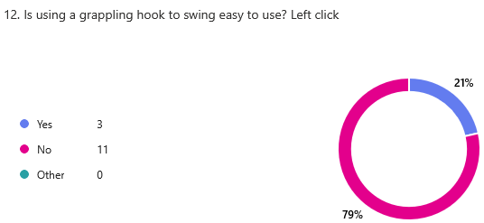  Stage 3.mp4 00:29 – grapple swing Stage 3.mp4 00:18 – bomb drop
Noises that play when an event happens in-game, like a jump or the player dying, can be created manually or by using royalty free ones online. |  | Not Met | In the user requirements analysis, this feature was tagged as desirable, but not essential. Due to this and placing it near to the end of the development plan, other aspects of the program were prioritised, and this wasn’t completed. To fix this in further development, I would add sound effects to a function that are played when it is executed.
Opponents that try to stop you from completing the level that you must either avoid or fight to survive, they would have ways of attacking like swords up close and projectiles from afar that you must avoid. |  | Partially Met | 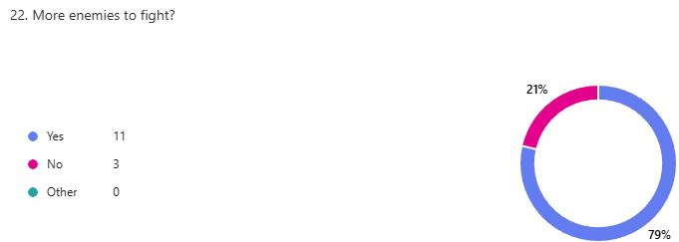  The reason for this component being marked as partially met is due to Stage 4 of development where the enemy design is described. It states that enemies should attack the player, and that the player takes damage/respawns when hit by one. While this does happen, indicated in test 1 and 2 of the test plan in Development Stage 4, I believe that creating more opponents for the player should have been prioritised as it adds more depth and different gameplay to the program. The need for a wider range of enemies is highlighted again in my post-development survey, where the majority of people answered yes to having more enemies. This is a feature I would work on in further development.  Stage 4.mp4 00:16 – Spikes  Stage 4.mp4 00:19 – Turret
A boss at the end of each level that the player must fight in order to complete it. They are harder than usual enemies and should have more weapons and health than the average opponent. |  | Not Met | This feature has been tagged as not met. The reason for this is that it isn’t an essential characteristic of the game. Due to its difficulty, prioritising it would result in other parts of the game losing quality or not working. This led me to strengthen and complete other areas of the program instead.
Respawning quickly at the start of each screen when the player dies to allow them to quickly retry the level. |  | Partially Met | Although the player does respawn quickly, in the development plan Stage 6 one of the features was that a transition animation would play every time the player dies, to seamlessly join the death and respawn together. This wasn’t completed due to focusing on the main parts of the game instead of animations. Another problem is that the player’s respawn point isn’t being changed for the enemies. This is an issue because when the player dies to one of them, it is reset to the very beginning of the level, and not to the most recent checkpoint. In continued development, I would fix this error and add animations to the player to make respawning less jarring and sudden.  Stage 4.mp4 00:04 – respawn
A game mode where you can fight with/against your friends |  | Not Met | This property was marked as ‘difficult to add’ and as ‘optional’ in the analysis, therefore it is a very low priority task as it would take a long time to complete, plus requiring other parts of the game to be fully complete like the player movement and tools. It is for these reasons that it is not met. I realised that in continuing with development, to create this feature, I could create a copy of the player, which is controlled by different inputs, that can damage/help the other player.
Hard mode - Where the player starts from the beginning of the level when they die compared to just the start of the screen they were on |  | Not Met | Similarly to the previous row, this was tagged as ‘optional’ in the analysis plus ‘not a necessary feature’. This wasn’t met due to it needing multiple levels to play in order to provide a challenge. As the level creation wasn’t prioritised, this feature wasn’t implemented. In further development, once more levels have been completed, I will add a feature that turns off checkpoints, adding a unique challenge to the game.

